## horizontal line

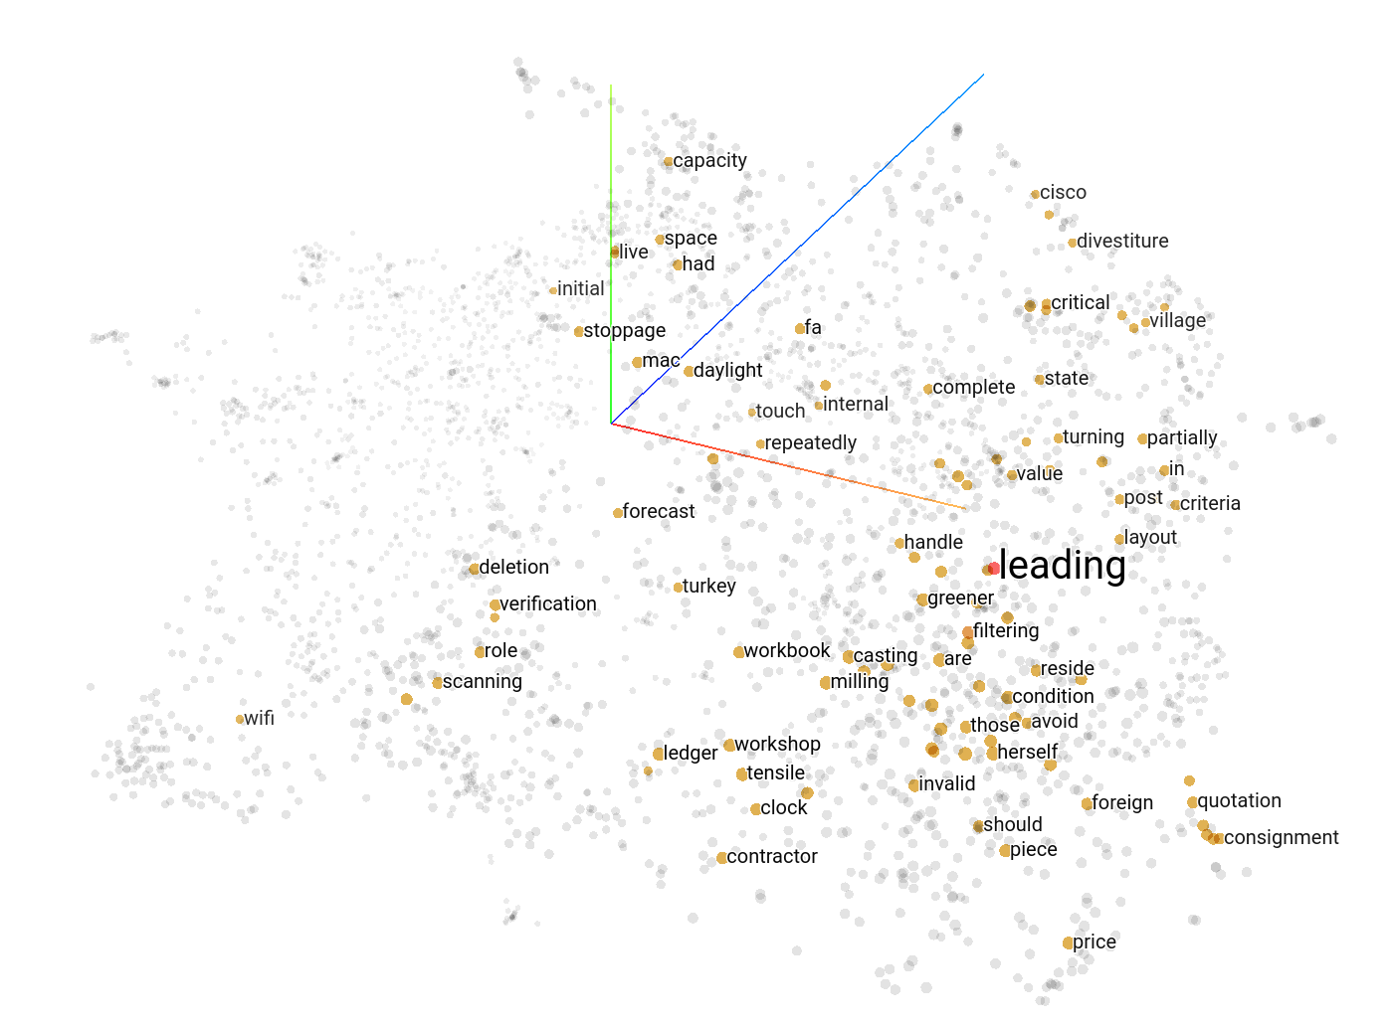

AIML Online Capstone - AUTOMATIC TICKET ASSIGNMENT - Final Report

December 27th, 2020

Vineeth Govind, Sridhar Krishnaswamy

AIML Online Batch Group 4 - Year 2020

Mentor: Sumit Kumar

Table of Contents

Summary of problem statement, data and findings

Current ‘Pain’ Points

Objective of this Project

Milestone - 2 : Where do we go from here (after reaching Milestone-1)?

Explore building a Neural Network Model from ground up using Continuous Bag of Words

Explore building a Neural Network Model from ground up using Word2Vec

Explore more visualization techniques

Explore Feature Engineering for Machine Learning

Apply Feature Engineering on a basic MLP or CNN model and see its performance.

Explore Model Interpretation techniques

Explore these Deep Learning Models & Fine tune the models with Hyper Parameter Tuning:

Attention Encoder-Decoder

Bi Directional LSTM (using Bayesian Hyper Parameter Tuning)

BiLSTM Performance with RandomSearch:

BERT initial run:

GPT2 initial run:

BERT vs GPT2

GPT2 with Hyperparams:

Explore approach for Production Implementation for Real-time calls to an API that can return the Group number the ticket is assigned to.

Closing Reflections

Limitations

Implications

Comparison to Benchmark

What have you learnt from the process?

---------------------------------------The above concludes Milestone-2-------------------------------------------

Initial Run of the Machine Learning & Deep Learning Models :

Deciding Models and Model Building

Machine Learning Models:

Deep Learning Models

Deep Learning Model Training with GloVe: Global Vectors for Word Representation.

How to improve your model performance?

Milestone - 1

Our Approach for Milestone-1

Our approach to Pre Processing

Dataset for Deep Learning

EDA (cont’d)

Document Clustering

Topic Modeling (aka Tagging)

Pre Processing (cont’d)

# Summary of problem statement, data and findings

Incident Management and Response is a key component of any IT Service Management Strategy. These are the typical steps involved in the Incident Management Process:

1. Receipt of the issue
2. Create a ticket
3. Review of the ticket by L1/L2 teams
4. Attempt to resolve the ticket using Standard Operating Procedures by L1/L2
5. If needed, transfer the ticket to the appropriate L3 team for further review and resolving.

### Current ‘Pain’ Points

Currently the organization sees these issues in the Incident Ticket Management Process:

1. The process is largely ‘manual’. L1/L2 teams need to spend time to review Standard Operating Procedures (SOPs) before assigning to functional teams. Minimum 25-30% incidents need to be reviewed for SOPs before ticket assignment.
2. **Minimum 1 FTE effort needed only for incident assignment to L3 teams**
3. Human error - many times the incident gets assigned to the wrong L3 team. So additional effort needed to reassign to the correct team after re-review of the ticket, this not only increases the manual effort needed BUT *also leads to customer dis-satisfaction because the customer who opened the ticket is left frustrated because the ticket is in limbo being tossed between various teams before getting to the actual team who can help resolve the issued.*

### Objective of this Project

The dataset provided has about 8500 records showing Ticket Long & Short Description, the caller, and the Group to which the Ticket has been assigned to.

Create various Machine Learning Models that can help classify incidents and assign them to the right Functional Group. Our objective is to create NLP models that can predict with at least 80% accuracy.

# Milestone - 2 : Where do we go from here (after reaching Milestone-1)?

For the second half of the project assignment, we decided to work on these aspects:

1. Explore building a Neural Network Model from ground up using Continuous Bag of Words
2. Explore building a Neural Network Model from ground up using Word2Vec
3. Explore more visualization techniques
4. Explore Feature Engineering
5. Apply Feature Engineering on a basic MLP or CNN model and see its performance.
6. Explore Model Interpretation techniques
7. Explore these Deep Learning Models & Fine tune the models with Hyper Parameter Tuning:
   1. Attention Encoder-Decoder
   2. Bi Directional LSTM
   3. BERT
   4. GPT2
8. Explore approach for Production Implementation for Real-time calls to an API that can return the Group number the ticket is assigned to.
9. Final Summary

## Explore building a Neural Network Model from ground up using Continuous Bag of Words

For details and the complete image, please refer to notebook: capstone_nlp_FeatureEngg.ipynb

1. We first build a word2vec model using a CBOW (Continuous Bag of Words) neural network architecture

Vocabulary Size: 4425

Vocabulary Sample: [('to', 1), ('the', 2), ('from', 3), ('in', 4), ('is', 5), ('please', 6), ('not', 7), ('and', 8),

1. We then build the context word generator. Given a list of words the function tries to generate the next possible word.

Context (X): ['login', 'issue', 'manager', 'name'] -> Target (Y): user

Context (X): ['issue', 'user', 'name', 'checked'] -> Target (Y): manager

Context (X): ['user', 'manager', 'checked', 'the'] -> Target (Y): name

Context (X): ['manager', 'name', 'the', 'name'] -> Target (Y): checked

Context (X): ['name', 'checked', 'name', 'in'] -> Target (Y): the

Context (X): ['checked', 'the', 'in', 'ad'] -> Target (Y): name

Context (X): ['the', 'name', 'ad', 'and'] -> Target (Y): in

Context (X): ['name', 'in', 'and', 'reset'] -> Target (Y): ad

Context (X): ['in', 'ad', 'reset', 'password'] -> Target (Y): and

Context (X): ['ad', 'and', 'password', 'advised'] -> Target (Y): reset

Context (X): ['and', 'reset', 'advised', 'to'] -> Target (Y): password

1. We build a Deep Network Model using Continous Bag of Words Technique:

cbow = Sequential()

cbow.add(Embedding(input_dim=vocab_size, output_dim=embed_size, input_length=window_size*2))

cbow.add(Lambda(lambda x: K.mean(x, axis=1), output_shape=(embed_size,)))

cbow.add(Dense(vocab_size, activation='softmax'))

cbow.compile(loss='categorical_crossentropy', optimizer='rmsprop')

print(cbow.summary())

Model: "sequential"

_________________________________________________________________

Layer (type) Output Shape Param #

=================================================================

embedding (Embedding) (None, 4, 100) 442500

_________________________________________________________________

lambda (Lambda) (None, 100) 0

_________________________________________________________________

dense (Dense) (None, 4425) 446925

=================================================================

Total params: 889,425

Trainable params: 889,425

Non-trainable params: 0

1. We train this model over 5 epochs.

Epoch: 1

Processed 100000 (context, word) pairs

Processed 200000 (context, word) pairs

Processed 300000 (context, word) pairs

Processed 400000 (context, word) pairs

Epoch: 2

Processed 100000 (context, word) pairs

Processed 200000 (context, word) pairs

Processed 300000 (context, word) pairs

Processed 400000 (context, word) pairs

Epoch: 3

Processed 100000 (context, word) pairs

Processed 200000 (context, word) pairs

Processed 300000 (context, word) pairs

Processed 400000 (context, word) pairs

Epoch: 4

Processed 100000 (context, word) pairs

Processed 200000 (context, word) pairs

Processed 300000 (context, word) pairs

Processed 400000 (context, word) pairs

Epoch: 5

Processed 100000 (context, word) pairs

Processed 200000 (context, word) pairs

Processed 300000 (context, word) pairs

Processed 400000 (context, word) pairs

1. We generate the word embeddings.

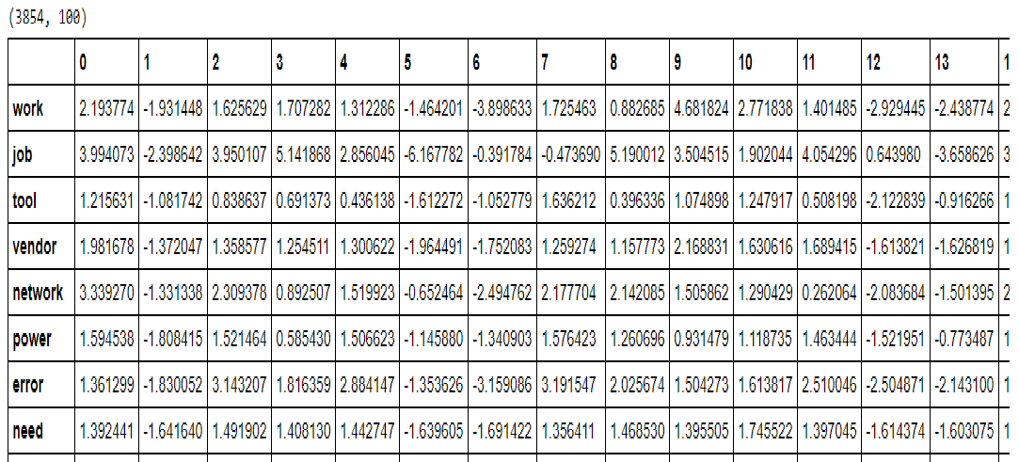

1. We then Build a distance matrix to view the most similar words (contextually)

{'lockout': ['frequent', 'town', 'duck', 'filterwithing', 'prognose'],

'network': ['take', 'make', 'hello', 'office', 'problem'],

'password': ['mail', 'meet', 'current', 'forward', 'every'],

'receive': ['tool', 'get', 'need', 'check', 'send'],

'schedule': ['immediately', 'telephony', 'true', 'lot', 'nothing'],

'system': ['go', 'one', 'order', 'error', 'issue'],

'ticket': ['show', 'one', 'set', 'plant', 'customer'],

'work': ['backup', 'need', 'site', 'maint', 'see']}

## Explore building a Neural Network Model from ground up using Word2Vec

1. We now implement a word2vec model using a skip-gram neural network architecture. We use the keras tokenizer API

tokenizer = text.Tokenizer()

tokenizer.fit_on_texts(mydata['Combined Description Cleaned'])

word2id = tokenizer.word_index

id2word = {v:k for k, v in word2id.items()}

1. Some sample skip grams ((word1, word2) -> relevancy)

Vocabulary Size: 3855

Vocabulary Sample: [('receive', 1), ('work', 2), ('job', 3), ('tool', 4), ('vendor', 5), ('network', 6), ('power', 7), ('error', 8), ('need', 9), ('issue', 10)]

(able (49), login (76)) -> 1

(advise (159), issue (10)) -> 1

(issue (10), able (49)) -> 1

(resolve (137), able (49)) -> 1

(password (24), gain (1570)) -> 0

(name (55), able (49)) -> 1

(check (34), space (188)) -> 0

(advise (159), ad (288)) -> 1

(caller (725), check (34)) -> 1

(issue (10), reg (2080)) -> 0

We also built a word2vec model using gensim

{'issue': ['error', 'problem', 'need', 'unable', 'onesue'],

'job': ['schedule', 'statistic', 'cluster', 'arc', 'abort'],

'login': ['connect', 'password', 'logwithin', 'log', 'relate'],

'manager': ['van', 'would', 'today', 'requirement', 'reply'],

'network': ['na', 'vendor', 'outage', 'power', 'yes'],

'password': ['thim', 'login', 'unlock', 'lock', 'pthessword'],

'schedule': ['job', 'scneverdule', 'arc', 'resume', 'cluster'],

'ticket': ['e', 'secure', 'telephoffy', 'telephouty', 'powder']}

## Explore more visualization techniques

The figure below shows the visualization of the word embeddings using TSNE.

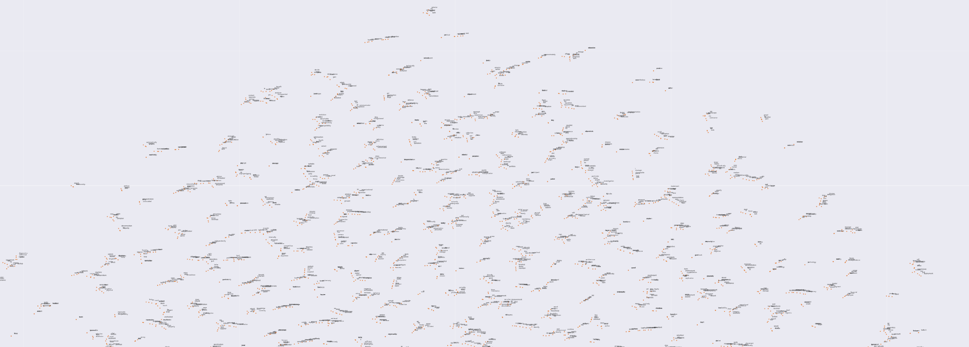

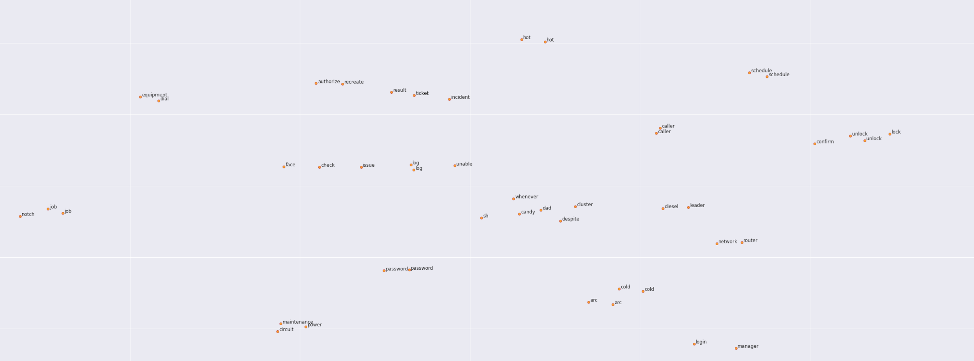

We also attempted to use the FastText library to create similar words:

{'issue': ['system', 'able', 'try', 'error', 'get'],

'job': ['schedule', 'arc', 'cold', 'abort', 'hot'],

'login': ['password', 'caller', 'unlock', 'log', 'kiosk'],

'manager': ['management', 'help', 'caller', 'able', 'hi'],

'network': ['power', 'outage', 'yes', 'circuit', 'divestiture'],

'password': ['management', 'reset', 'unlock', 'lock', 'login'],

'schedule': ['job', 'arc', 'cold', 'hot', 'abort'],

'ticket': ['remote', 'incident', 'network', 'yes', 'type']}

We think the techniques we used earlier in Milestone-1 for Data Augmentation yielded better ‘synonyms’.

## Explore Feature Engineering for Machine Learning

For details, please refer to notebook: capstone_nlp_FeatureEngg-Part2.ipynb

The text and diagram presented here are borrowed from <https://medium.com/wisio/a-gentle-introduction-to-doc2vec-db3e8c0cce5e>

https://towardsdatascience.com/another-twitter-sentiment-analysis-with-python-part-6-doc2vec-603f11832504

Having tried the Word2Vec in Milesone-1, we decided to try out Doc2Vec in this iteration. Doc2vec is a method first presented in 2014 by **Mikilov and Le** in this [article](https://arxiv.org/abs/1405.4053)

What is Doc2Vec and How different is it from **word2vec**:

**word2vec** is a well known concept, used to generate representation vectors out of words. In general, when you like to build some model using words, simply labeling/one-hot encoding them is a plausible way to go. However, when using such encoding, the words lose their meaning. e.g, if we encode *Paris* as *id_4*, *France* as *id_6* and *power* as *id_8*, *France* will have the same relation to *power* as with *Paris*. We would prefer a representation in which *France* and *Paris* will be closer than *France* and *power*.

Such representations, encapsulate different relations between words, like synonyms, antonyms, or analogies, such as this one:

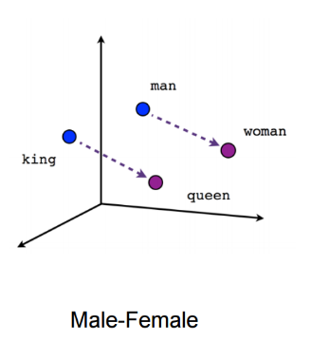

word2vec representation is created using 2 algorithms: Continuous Bag-of-Words model (**CBOW**) and the **Skip-Gram** model.

The goal of **doc2vec** is to create a numeric representation of a document, regardless of its length. But unlike words, documents do not come in logical structures such as words, so the another method has to be found.

The concept that Mikilov and Le have used was simple, yet clever: they have used the **word2vec** model, and added another vector (Paragraph ID below), like so:

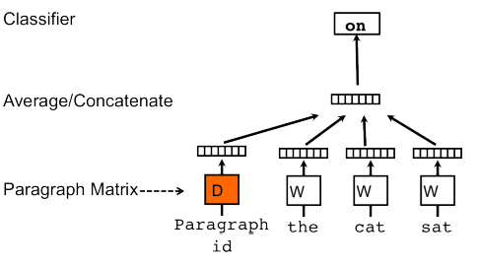

So, when training the word vectors W, the document vector D is trained as well, and in the end of training, it holds a numeric representation of the document.

The model above is called *Distributed Memory version of Paragraph Vector* (PV-DM). It acts as a memory that remembers what is missing from the current context — or as the topic of the paragraph. While the word vectors represent the concept of a word, the document vector intends to represent the concept of a document.

There is also another technique Distributed Bag of Words.

DBOW: This is the Doc2Vec model analogous to Skip-gram model in Word2Vec. The paragraph vectors are obtained by training a neural network on the task of predicting a probability distribution of words in a paragraph given a randomly-sampled word from the paragraph.

We tried out these techniques:

1. DBOW (Distributed Bag of Words)
2. DMC (Distributed Memory Concatenated)
3. DMM (Distributed Memory Mean)
4. DBOW + DMC
5. DBOW + DMM

We created unigrams, bigrams and tri-grams using each of the above techniques and ran the Logistic Regression classifier to evaluate the results.

Sample vectors:

LabeledSentence(words=['master', 'by', 'are', 'in', 'and', 'material', 'report', 'statistics', 'extended', 'on', 'august', 'which', 'we', 'had', 'to', 'correct', 'this', 'morning', 'today', 'that', 'were', 'blank', 'corrected', 'if', 'manually', 'these', 'the', 'system', 'does', 'not', 'allow', 'us', 'save', 'with', 'a', 'blank', 'need', 'populate', 'these'], tags=['all_26342']),

LabeledSentence(words=['when', 'grade', 'on', 'material', 'engineering', 'utility', 'is', 'not', 'if', 'selected', 'used', 'to', 'change', 'the', 'a', 'logic', 'that', 'valid', 'for', 'new', 'grade', 'this', 'working', 'correctly', 'save', 'id', 'screen', 'and', 'invalid', 'are', 'being', 'left', 'affecting', 'all', 'just', 'one', 'needs', 'corrected', 'save', 'delete'], tags=['all_22260']),

LabeledSentence(words=['our', 'we', 'the', 'error', 'message', 'transfer', 'unit', 'missing'], tags=['all_2149']),

LabeledSentence(words=['wrong', 'in', 'received', 'from', 'hello', 'a', 'drawing', 'was', 'saved', 'under', 'the', 'number', 'hesitate', 'delete', 'best'], tags=['all_24441']),

LabeledSentence(words=['collaboration', 'platform', 'site', 'request', 'hello', 'can', 'you', 'add', 'the', 'below', 'to', 'as', 'team', 'i', 'should', 'have', 'ownership', 'edit', 'access'], tags=['all_364']),

LabeledSentence(words=['job', 'job', 'in', 'job', 'schedule', 'time', 'received', 'from', 'connection', 'error', 'to', 'system'], tags=['all_22246']),

LabeledSentence(words=['tool', 'application', 'sending', 'multiple', 'via', 'hi', 'as', 'there', 'send', 'also', 'out', 'of', 'on', 'a', 'daily', 'basis', 'the', 'server', 'same', 'for', 'last', 'since', 'th', 'are', 'duplicate', 'example', 'see', 'attached', 'i', 'have', 'been', 'daily', 'one', 'more', 'thing', 'to', 'note', 'is', 'that', 'count', 'sent', 'per', 'day', 'but', 'not', 'doubled', 'be', 'it', 'twice', 'instead', 'them', 'times', 'issue', 'escalate', 'higher', 'management', 'greatly', 'appreciate', 'if', 'you', 'could', 'look', 'into', 'this', 'let', 'me', 'know', 'need'], tags=['all_17176']),

Then we attempted to create similar words to some of the words in our Auto Ticket Assignment vocab:

model_ug_dmc.most_similar('network')

[('dynamic', 0.5188397169113159),

('legible', 0.4633473753929138),

('wireless', 0.46207863092422485),

('electromechanical', 0.45785877108573914),

('estate', 0.4521123170852661),

('circuit', 0.42887771129608154),

('divestiture', 0.4207233786582947),

('spread', 0.41820594668388367),

('gecko', 0.4153391718864441),

('cat', 0.4108252227306366)]

Pretty impressive results if once considers the fact tht CAT is actually a network terminology!!!

The actual scores returned using the trigram is shown here. Please refer to the notebook capstone_nlp_FeatureEngg-Part2.ipynb

RESULT FOR TRIGRAM WITH STOP WORDS (Tfidf)

LogisticRegression(C=1.0, class_weight=None, dual=False, fit_intercept=True,

intercept_scaling=1, l1_ratio=None, max_iter=1000,

multi_class='auto', n_jobs=None, penalty='l2',

random_state=None, solver='lbfgs', tol=0.0001, verbose=0,

warm_start=False)

Validation result for 10000 features

null accuracy: 88.14%

accuracy score: 86.54%

model is 1.60% less accurate than null accuracy

train and test time: 91.88s

--------------------------------------------------------------------------------

Validation result for 20000 features

null accuracy: 88.14%

accuracy score: 87.50%

model is 0.64% less accurate than null accuracy

train and test time: 116.03s

--------------------------------------------------------------------------------

Validation result for 30000 features

null accuracy: 88.14%

accuracy score: 87.82%

model is 0.32% less accurate than null accuracy

train and test time: 138.31s

--------------------------------------------------------------------------------

Validation result for 40000 features

null accuracy: 88.14%

accuracy score: 87.50%

model is 0.64% less accurate than null accuracy

train and test time: 163.69s

--------------------------------------------------------------------------------

Validation result for 50000 features

null accuracy: 88.14%

accuracy score: 88.14%

model has the same accuracy with the null accuracy

train and test time: 181.48s

--------------------------------------------------------------------------------

Validation result for 60000 features

null accuracy: 88.14%

accuracy score: 87.18%

model is 0.96% less accurate than null accuracy

train and test time: 193.35s

--------------------------------------------------------------------------------

Validation result for 70000 features

null accuracy: 88.14%

accuracy score: 87.82%

model is 0.32% less accurate than null accuracy

train and test time: 221.55s

--------------------------------------------------------------------------------

Validation result for 80000 features

null accuracy: 88.14%

accuracy score: 89.10%

model is 0.96% more accurate than null accuracy

train and test time: 239.93s

--------------------------------------------------------------------------------

Validation result for 90000 features

null accuracy: 88.14%

accuracy score: 89.42%

model is 1.28% more accurate than null accuracy

train and test time: 245.18s

--------------------------------------------------------------------------------

Validation result for 100000 features

null accuracy: 88.14%

accuracy score: 89.42%

model is 1.28% more accurate than null accuracy

train and test time: 261.37s

--------------------------------------------------------------------------------

CPU times: user 38min 27s, sys: 31min 57s, total: 1h 10min 25s

Wall time: 30min 52s

Then we attempted Dimensionality Reduction using Chi2.

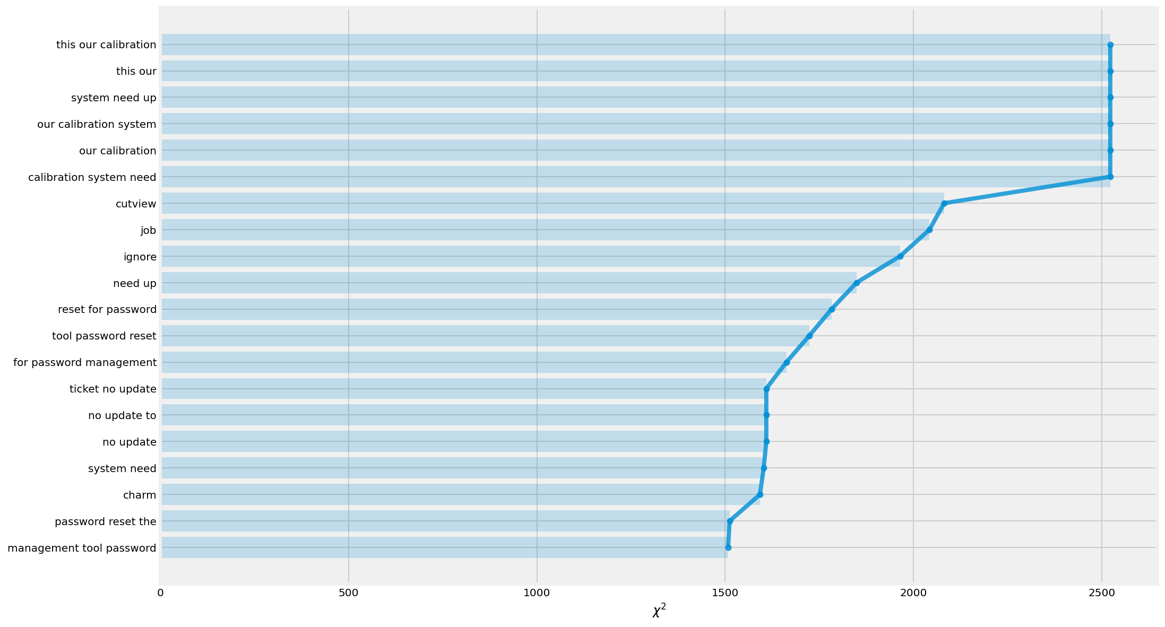

Finally we attempted to Explain the features using PCA:

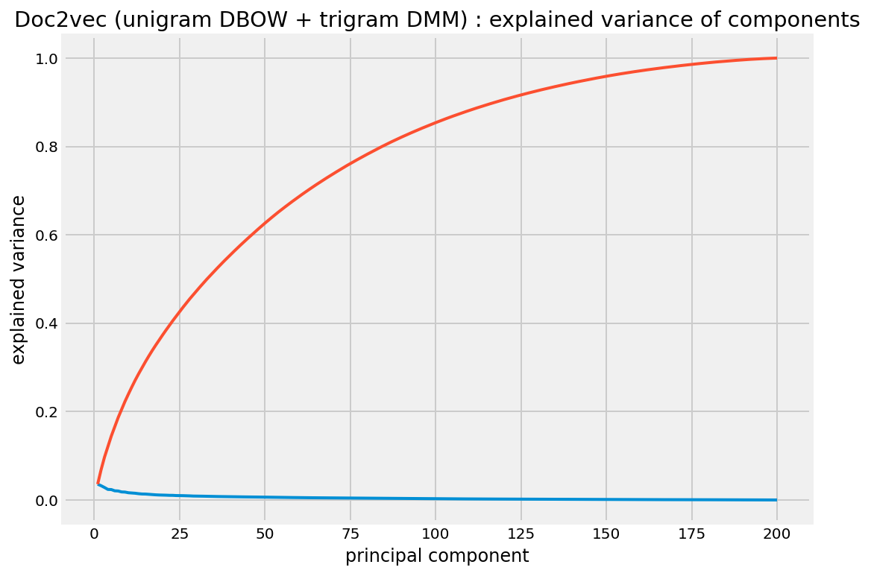

**The above graph shows the optimal number of features is 175 to explain at least 95% variance.**

## Apply Feature Engineering on a basic MLP or CNN model and see its performance.

For details please refer to notebook: capstone_nlp_FeatureEngg-NN-Part3.ipynb.

We concatenated the Unigram and Trigram vectors and provided them as input to a simple MLP model:

model_d2v_06 = Sequential()

model_d2v_06.add(Dense(128, activation='relu', input_dim=200))

model_d2v_06.add(Dense(128, activation='relu'))

model_d2v_06.add(Dense(128, activation='relu'))

model_d2v_06.add(Dense(74, activation='softmax'))

model_d2v_06.compile(optimizer='adam',

loss='categorical_crossentropy',

metrics=['accuracy'])

Epoch 1/10

781/781 - 2s - loss: 2.4543 - accuracy: 0.3675 - val_loss: 1.8468 - val_accuracy: 0.4725

Epoch 2/10

781/781 - 2s - loss: 1.5588 - accuracy: 0.5582 - val_loss: 1.4775 - val_accuracy: 0.5682

Epoch 3/10

781/781 - 2s - loss: 1.1528 - accuracy: 0.6608 - val_loss: 1.2146 - val_accuracy: 0.6323

Epoch 4/10

781/781 - 2s - loss: 0.8901 - accuracy: 0.7319 - val_loss: 1.1318 - val_accuracy: 0.6685

Epoch 5/10

781/781 - 2s - loss: 0.7100 - accuracy: 0.7859 - val_loss: 1.0117 - val_accuracy: 0.7050

Epoch 6/10

781/781 - 2s - loss: 0.5812 - accuracy: 0.8173 - val_loss: 0.9748 - val_accuracy: 0.7124

Epoch 7/10

781/781 - 2s - loss: 0.4927 - accuracy: 0.8445 - val_loss: 0.9662 - val_accuracy: 0.7136

Epoch 8/10

781/781 - 2s - loss: 0.4266 - accuracy: 0.8662 - val_loss: 0.9688 - val_accuracy: 0.7188

Epoch 9/10

781/781 - 2s - loss: 0.3648 - accuracy: 0.8828 - val_loss: 0.9658 - val_accuracy: 0.7252

Epoch 10/10

781/781 - 2s - loss: 0.3240 - accuracy: 0.8943 - val_loss: 0.9607 - val_accuracy: 0.7335

<tensorflow.python.keras.callbacks.History at 0x7f13c9e2b240>

We implemented Word2Vec models, one with CBOW (Continuous Bag Of Words) model, and the other with skip-gram model. CBOW model predicts the current word from a window of surrounding context words, while Skip-gram model predicts surrounding context words given the current word. In Gensim package, you can specify whether to use CBOW or Skip-gram by passing the argument “sg” when implementing Word2Vec. By default (sg=0), CBOW is used. Otherwise (sg=1), skip-gram is employed.

from gensim.models import KeyedVectors

model_ug_cbow = KeyedVectors.load('w2v_model_ug_cbow.word2vec')

model_ug_sg = KeyedVectors.load('w2v_model_ug_sg.word2vec')

embeddings_index = {}

for w in model_ug_cbow.wv.vocab.keys():

embeddings_index[w] = np.append(model_ug_cbow.wv[w],model_ug_sg.wv[w])

Keras’ ‘Tokenizer’ will split each word in a sentence, then we can call ‘texts_to_sequences’ method to get a sequential representation of each sentence. We also need to pass ‘num_words’ which is a number of vocabularies you want to use, and this will be applied when you call ‘texts_to_sequences’ method.

from keras.preprocessing.text import Tokenizer

from keras.preprocessing.sequence import pad_sequences

tokenizer = Tokenizer(num_words=100000)tokenizer.fit_on_texts(x_train)sequences = tokenizer.texts_to_sequences(x_train)

The maximum number of words in a sentence within the training data is 150. Let’s decide the maximum length to be a bit longer than this, let’s say 155.

sequences_val = tokenizer.texts_to_sequences(x_validation)

x_val_seq = pad_sequences(sequences_val, maxlen=155)

We will use Embedding layer in Keras. With Embedding layer, we can either pass pre-defined embedding, which we prepared as ‘embedding_matrix’ above, or Embedding layer itself can learn word embeddings as the whole model trains. And another possibility is we can still feed the pre-defined embedding but make it trainable so that it will update the values of vectors as the model trains.In order to check which method performs better, we defined a simple shallow neural network with one hidden layer.

We first defined a simple CNN as shown below:

Model: "model"

__________________________________________________________________________________________________

Layer (type) Output Shape Param # Connected to

==================================================================================================

input_1 (InputLayer) [(None, 200)] 0

__________________________________________________________________________________________________

embedding_9 (Embedding) (None, 200, 200) 20000000 input_1[0][0]

__________________________________________________________________________________________________

conv1d_6 (Conv1D) (None, 199, 100) 40100 embedding_9[0][0]

__________________________________________________________________________________________________

conv1d_7 (Conv1D) (None, 198, 100) 60100 embedding_9[0][0]

__________________________________________________________________________________________________

conv1d_8 (Conv1D) (None, 197, 100) 80100 embedding_9[0][0]

__________________________________________________________________________________________________

global_max_pooling1d_5 (GlobalM (None, 100) 0 conv1d_6[0][0]

__________________________________________________________________________________________________

global_max_pooling1d_6 (GlobalM (None, 100) 0 conv1d_7[0][0]

__________________________________________________________________________________________________

global_max_pooling1d_7 (GlobalM (None, 100) 0 conv1d_8[0][0]

__________________________________________________________________________________________________

concatenate (Concatenate) (None, 300) 0 global_max_pooling1d_5[0][0]

global_max_pooling1d_6[0][0]

global_max_pooling1d_7[0][0]

__________________________________________________________________________________________________

dense_14 (Dense) (None, 256) 77056 concatenate[0][0]

__________________________________________________________________________________________________

dropout (Dropout) (None, 256) 0 dense_14[0][0]

__________________________________________________________________________________________________

dense_15 (Dense) (None, 74) 19018 dropout[0][0]

__________________________________________________________________________________________________

activation (Activation) (None, 74) 0 dense_15[0][0]

==================================================================================================

Total params: 20,276,374

Trainable params: 20,276,374

Non-trainable params: 0

Epoch 1/5

781/781 [==============================] - 91s 115ms/step - loss: 2.5075 - accuracy: 0.3919 - val_loss: 0.7200 - val_accuracy: 0.7944

Epoch 2/5

781/781 [==============================] - 89s 115ms/step - loss: 0.6113 - accuracy: 0.8314 - val_loss: 0.3773 - val_accuracy: 0.8901

Epoch 3/5

781/781 [==============================] - 90s 115ms/step - loss: 0.3056 - accuracy: 0.9104 - val_loss: 0.3877 - val_accuracy: 0.8831

Epoch 4/5

781/781 [==============================] - 89s 114ms/step - loss: 0.2449 - accuracy: 0.9255 - val_loss: 0.3417 - val_accuracy: 0.8985

Epoch 5/5

781/781 [==============================] - 90s 115ms/step - loss: 0.1812 - accuracy: 0.9434 - val_loss: 0.3387 - val_accuracy: 0.9023

<tensorflow.python.keras.callbacks.History at 0x7fdb615f3780>

In the final run we merged the bi-gram, tri-gram, four-gram vectors as shown below:

(For details please refer to notebook: capstone_nlp_FeatureEngg_Part4_cnn_w2v.ipynb)

ticket_input = Input(shape=(200,), dtype='int32')

ticket_encoder = Embedding(100000, 200, weights=[embedding_matrix], input_length=200, trainable=**True**)(ticket_input)

bigram_branch = Conv1D(filters=100, kernel_size=2, padding='valid', activation='relu', strides=1)(ticket_encoder)

bigram_branch = GlobalMaxPooling1D()(bigram_branch)

trigram_branch = Conv1D(filters=100, kernel_size=3, padding='valid', activation='relu', strides=1)(ticket_encoder)

trigram_branch = GlobalMaxPooling1D()(trigram_branch)

fourgram_branch = Conv1D(filters=100, kernel_size=4, padding='valid', activation='relu', strides=1)(ticket_encoder)

fourgram_branch = GlobalMaxPooling1D()(fourgram_branch)

merged = concatenate([bigram_branch, trigram_branch, fourgram_branch], axis=1)

merged = Dense(256, activation='relu')(merged)

merged = Dropout(0.2)(merged)

merged = Dense(74)(merged)

output = Activation('softmax')(merged)

model = Model(inputs=[ticket_input], outputs=[output])

model.compile(loss='categorical_crossentropy',

optimizer='adam',

metrics=['accuracy'])

model.summary()

Model: "model"

__________________________________________________________________________________________________

Layer (type) Output Shape Param # Connected to

==================================================================================================

input_1 (InputLayer) [(None, 200)] 0

__________________________________________________________________________________________________

embedding_9 (Embedding) (None, 200, 200) 20000000 input_1[0][0]

__________________________________________________________________________________________________

conv1d_6 (Conv1D) (None, 199, 100) 40100 embedding_9[0][0]

__________________________________________________________________________________________________

conv1d_7 (Conv1D) (None, 198, 100) 60100 embedding_9[0][0]

__________________________________________________________________________________________________

conv1d_8 (Conv1D) (None, 197, 100) 80100 embedding_9[0][0]

__________________________________________________________________________________________________

global_max_pooling1d_5 (GlobalM (None, 100) 0 conv1d_6[0][0]

__________________________________________________________________________________________________

global_max_pooling1d_6 (GlobalM (None, 100) 0 conv1d_7[0][0]

__________________________________________________________________________________________________

global_max_pooling1d_7 (GlobalM (None, 100) 0 conv1d_8[0][0]

__________________________________________________________________________________________________

concatenate (Concatenate) (None, 300) 0 global_max_pooling1d_5[0][0]

global_max_pooling1d_6[0][0]

global_max_pooling1d_7[0][0]

__________________________________________________________________________________________________

dense_14 (Dense) (None, 256) 77056 concatenate[0][0]

__________________________________________________________________________________________________

dropout (Dropout) (None, 256) 0 dense_14[0][0]

__________________________________________________________________________________________________

dense_15 (Dense) (None, 74) 19018 dropout[0][0]

__________________________________________________________________________________________________

activation (Activation) (None, 74) 0 dense_15[0][0]

==================================================================================================

Total params: 20,276,374

Trainable params: 20,276,374

Non-trainable params: 0

We then attempted an Hyper Parameter Tuning with Random Search:

Trial 10 Complete [00h 27m 58s]

val_accuracy: 0.9061499238014221

Best val_accuracy So Far: 0.9167200326919556

Total elapsed time: 04h 49m 52s

INFO:tensorflow:Oracle triggered exit

Epoch 1/100

1561/1561 [==============================] - 169s 108ms/step - loss: 0.2487 - accuracy: 0.9199 - val_loss: 0.3775 - val_accuracy: 0.9061

Learning Rate = <tf.Variable 'Adam/learning_rate:0' shape=() dtype=float32, numpy=0.001>

Epoch 2/100

1561/1561 [==============================] - 168s 107ms/step - loss: 0.2547 - accuracy: 0.9234 - val_loss: 0.4267 - val_accuracy: 0.9017

Learning Rate = <tf.Variable 'Adam/learning_rate:0' shape=() dtype=float32, numpy=0.001>

Epoch 3/100

1561/1561 [==============================] - 168s 108ms/step - loss: 0.2379 - accuracy: 0.9281 - val_loss: 0.4342 - val_accuracy: 0.9081

Learning Rate = <tf.Variable 'Adam/learning_rate:0' shape=() dtype=float32, numpy=0.001>

Epoch 4/100

1561/1561 [==============================] - 168s 108ms/step - loss: 0.2356 - accuracy: 0.9278 - val_loss: 0.4028 - val_accuracy: 0.9116

Learning Rate = <tf.Variable 'Adam/learning_rate:0' shape=() dtype=float32, numpy=0.001>

Epoch 5/100

1561/1561 [==============================] - 168s 108ms/step - loss: 0.2315 - accuracy: 0.9305 - val_loss: 0.4783 - val_accuracy: 0.9042

Learning Rate = <tf.Variable 'Adam/learning_rate:0' shape=() dtype=float32, numpy=0.001>

Epoch 6/100

1561/1561 [==============================] - 168s 108ms/step - loss: 0.2179 - accuracy: 0.9329 - val_loss: 0.4472 - val_accuracy: 0.9084

Learning Rate = <tf.Variable 'Adam/learning_rate:0' shape=() dtype=float32, numpy=0.001>

Epoch 00006: early stopping

## Explore Model Interpretation techniques

We used ELI5 to explain the model results from Logistic Regression. For details please refer to notebook capstone-nlp-ML-Model-interpretation.ipynb

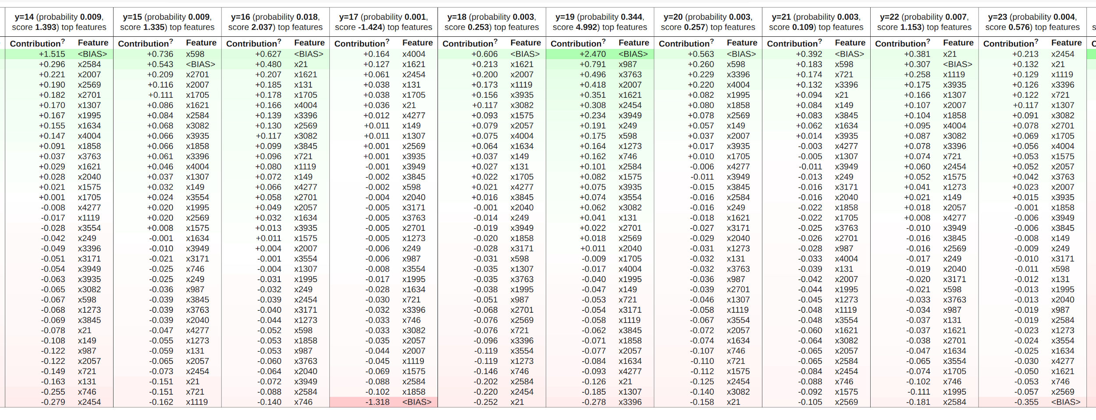

## Explore these Deep Learning Models & Fine tune the models with Hyper Parameter Tuning:

### Attention Encoder-Decoder

We attempted to tune these parameters using Bayesian using Keras HyperTuner:

* Learning rate
* Batch Size

The code is below:

#Attention with encoder decoder

inp = Embedding(max_features,emb_dim,input_length=inp_len)(inputs)

lstm_out = LSTM(64, return_sequences=**True**)(inp)

attention = Dense(1, activation='relu')(lstm_out)

attention = Flatten()(attention)

attention = Activation('softmax')(attention)

attention = RepeatVector(64)(attention)

#attention = LSTM(64,return_sequences=False)(attention)

attention = Permute([2,1])(attention)

combined = concatenate([lstm_out, attention])

combined_mul = Flatten()(combined)

decode = RepeatVector(64)(combined_mul)

decode = LSTM(64, return_sequences=**True**)(decode)

decode=Flatten()(decode)

decode = (Dense(74))(decode)

decode = Activation('softmax')(decode)

model_enc_dec_att = tf.keras.Model(inputs=inputs, outputs=decode)

model_enc_dec_att.compile(optimizer='adam', loss='categorical_crossentropy',metrics = ['accuracy'])

print(model_enc_dec_att.summary())

def ENC_DEC_ATT_model(hp):*#attention with encoder decoder*

model = model_enc_dec_att

print(model.summary())

lr = hp.Choice('learning_rate', [1e-2, 1e-3, 1e-4])

model.compile(optimizer='adam',

loss='categorical_crossentropy',

metrics=['accuracy'])

return model

Hyperparameters for ENC_DEC_ATT are

{'learning_rate': 0.001, 'batch_size': 128}

The training stops at 9 epochs due to early stopping callback.

### 

### 

### Bi Directional LSTM (using Bayesian Hyper Parameter Tuning)

Please refer to notebook capstone-nlp-DL-GlOve-BILSTM.ipynb

We attempted to tune these parameters using Bayesian, Random Search techniques using Keras HyperTuner:

* Units for each layer (eg: Dense, LSTM, DropOut)
* Learning rate
* Momentum
* Epochs
* Batch Size

Only Bayesian allowed us to tune the epochs & batch size . The code is below:

def build_model(hp):

#word_index, embeddings_matrix, nclasses = get_params()

model = Sequential()

hidden_layer = 6

#gru_node = 32

dropout=0.2

#HP_DROPOUT = hp2.HParam('dropout', hp2.RealInterval(0.1, 0.2))

model.add(Embedding(len(word_index) + 1,

EMBEDDING_DIM,

weights=[embedding_matrix],

input_length=MAX_SEQUENCE_LENGTH,

trainable=True))

#print(gru_node)

for i in range(0,hidden_layer):

model.add(tf.keras.layers.Bidirectional(tf.compat.v1.keras.layers.CuDNNLSTM(

units=hp.Int('lstm_node_1_units', min_value=16, max_value=256, step=16),

#units=hp.Choice('lstm_node_1_units', values = [32,128,256]),

return_sequences=True

)))

model.add(

Dropout(

hp.Choice('dropout_1', values = [0.1,0.2,0.3,0.4,0.5]),

))

model.add(BatchNormalization())

model.add(tf.keras.layers.Bidirectional(

#tf.compat.v1.keras.layers.CuDNNGRU(gru_node)

tf.compat.v1.keras.layers.CuDNNLSTM(

units=hp.Int('lstm_node_2_units', min_value=16, max_value=256, step=16)

#units=hp.Choice('lstm_node_2_units', values = [32,128,256])

)))

model.add(

Dropout(

hp.Choice('dropout_2', values = [0.1,0.2,0.3,0.4,0.5]),

))

model.add(BatchNormalization())

model.add(

#Dense(256, activation='relu')

Dense(units=hp.Int('dense_1_units', min_value=32, max_value=512, step=16),

#units=hp.Choice('dense_1_units', values = [32,128,256]),

activation='relu'

))

model.add(BatchNormalization())

model.add(Dense(74, activation='softmax'))

#lr = hp.Choice('learning_rate', values=[0.001, 1e-2, 1e-3, 1e-4])

#momentum = hp.Choice('momentum', values=[0.0, 0.2, 0.4, 0.6, 0.8, 0.9])

optimizer=tf.keras.optimizers.SGD(hp.Choice('learning_rate', values = [1e-2, 1e-3, 1e-4]),

hp.Choice('momentum', values=[0.0, 0.2, 0.4, 0.6, 0.8, 0.9]))

model.compile(optimizer=optimizer,

loss = 'sparse_categorical_crossentropy',

metrics=['accuracy']

)

return model

tuner_search = RandomSearch(build_model,

objective='val_accuracy',

max_trials=100,

directory='outputs',

project_name='TicketAssignment'

)

class MyTuner(kt.tuners.BayesianOptimization):

def run_trial(self, trial, *args, **kwargs):

# You can add additional HyperParameters for preprocessing and custom training loops

# via overriding `run_trial`

kwargs['batch_size'] = trial.hyperparameters.Int('batch_size', 16, 256, step=32)

super(MyTuner, self).run_trial(trial, *args, **kwargs)

The results achieved are shown below: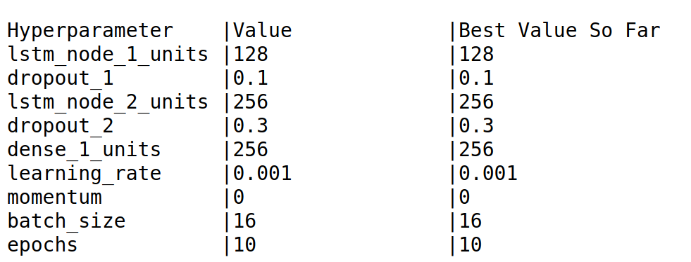

The model is able to achieve high accuracy with the least number of epochs when the batch_size is set to 16.

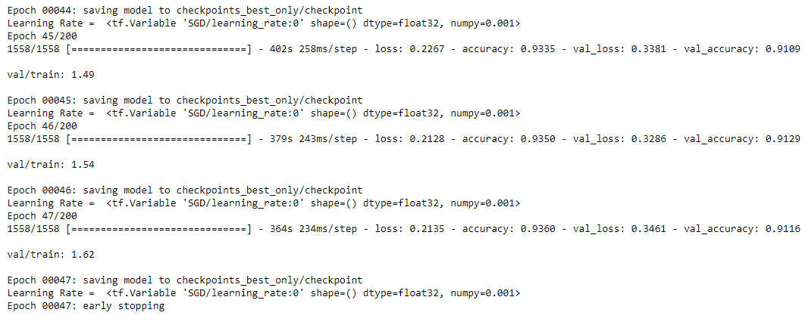

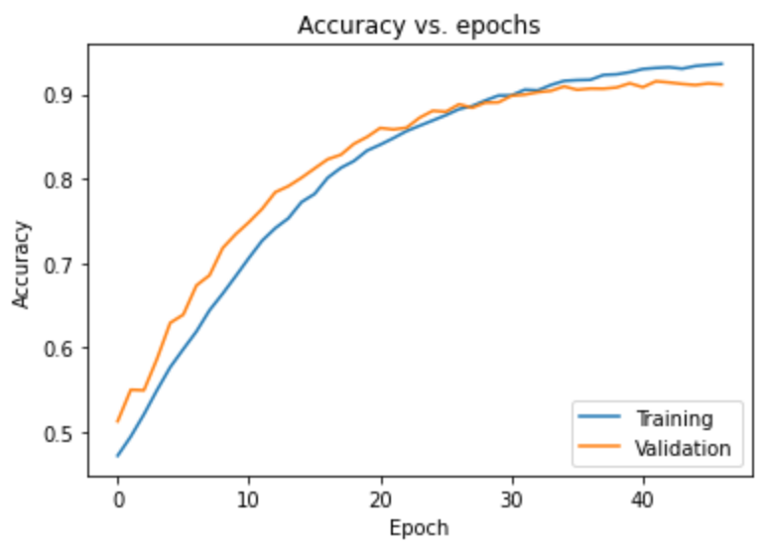

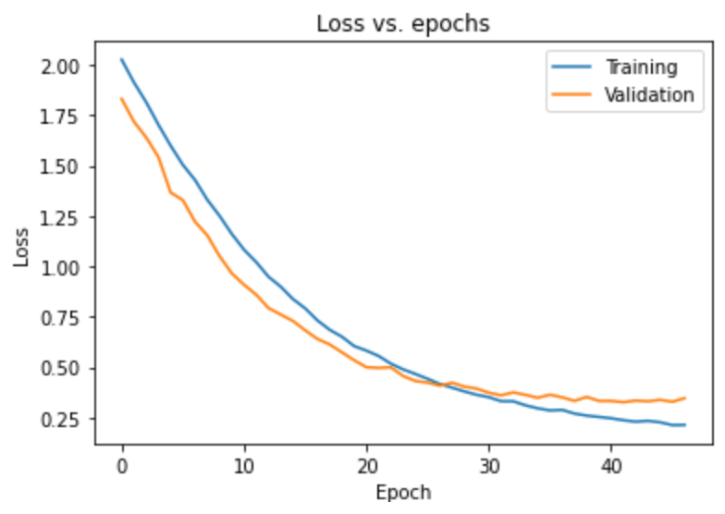

## BiLSTM Performance with RandomSearch:

Please refer to notebook capstone_nlp_DL_GlOve_BILSTM_RandomSearch.ipynb

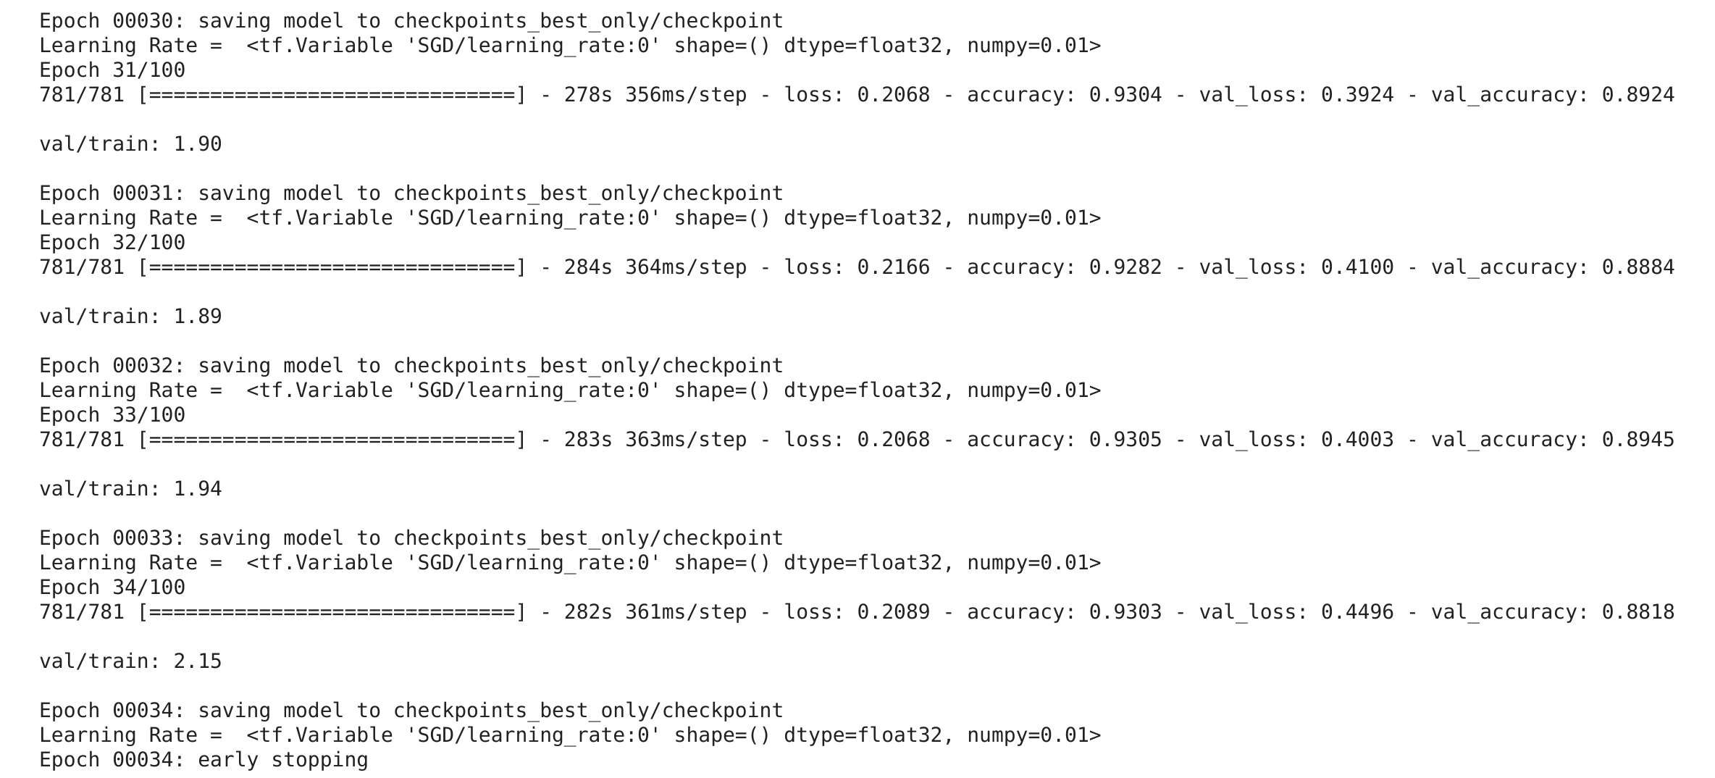

Evaluation Accuracy: 0.882

Evaluation Loss: 0.450

Mean Accuracy for the validation dataset:

0.8372015216771294

Mean Loss for the validation dataset:

0.5667102152810377

Mean Accuracy for the training dataset:

0.8577045763240141

Mean Loss for the training dataset:

0.4572651806999655

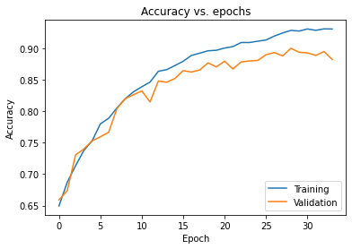

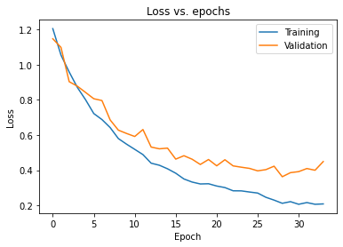

## BERT initial run:

Please refer to notebook Bert-Transformers.ipynb

[**http://jalammar.github.io/illustrated-gpt2/**](http://jalammar.github.io/illustrated-gpt2/)

[**https://www.topbots.com/generalized-language-models-bert-openai-gpt2/**](https://www.topbots.com/generalized-language-models-bert-openai-gpt2/)

**BERT**, short for **Bidirectional Encoder Representations from Transformers** ([Devlin, et al., 2019](https://arxiv.org/abs/1810.04805)) is a direct descendant to [GPT](https://topbots.com/generalized-language-models-ulmfit-openai-gpt/#openai-gpt): train a large language model on free text and then fine-tune on specific tasks without customized network architectures.

Compared to GPT, the largest difference and improvement of BERT is to make training **bi-directional**. The model learns to predict both context on the left and right. The paper according to the ablation study claimed that:

Determining Sequence Length:

## 

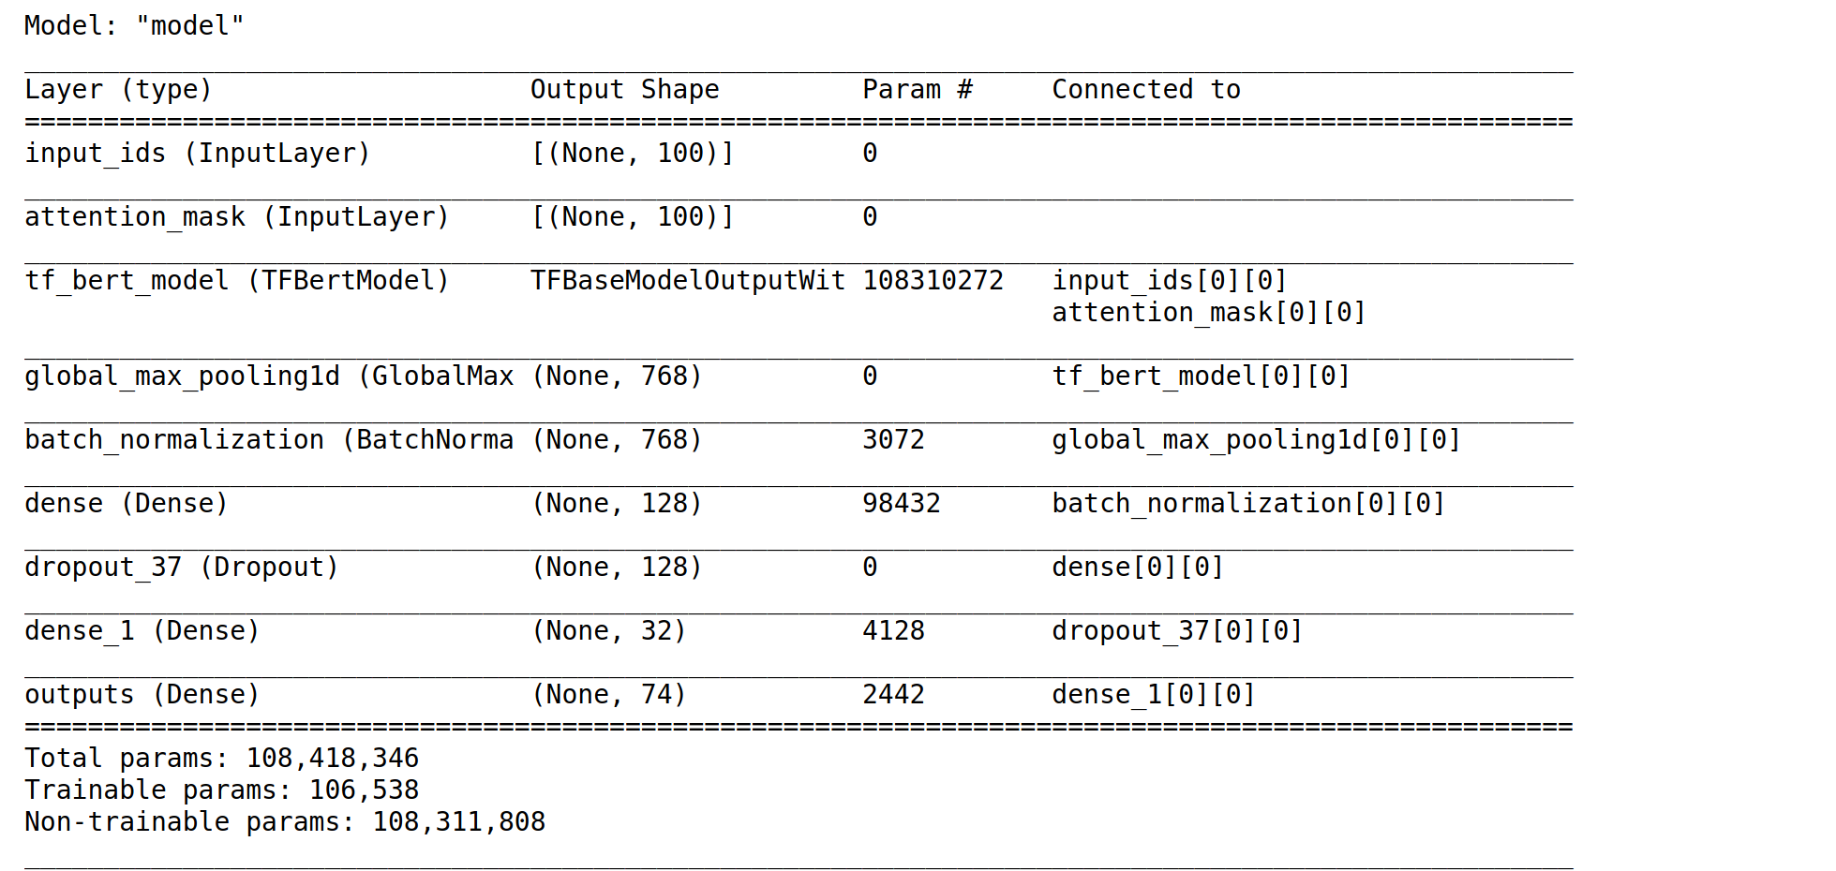

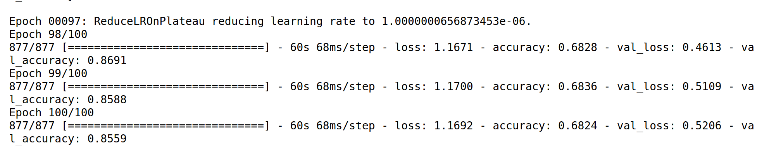

Evaluation Accuracy: 0.864

Evaluation Loss: 0.475

Mean Accuracy for the validation dataset:

0.8167302113771439

Mean Loss for the validation dataset:

0.6493391236662864

Mean Accuracy for the training dataset:

0.6322445100545884

Mean Loss for the training dataset:

1.3612296533584596

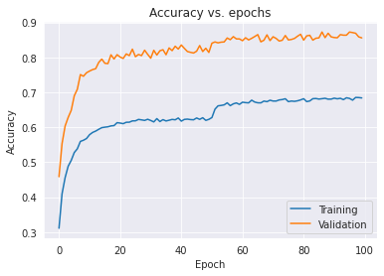

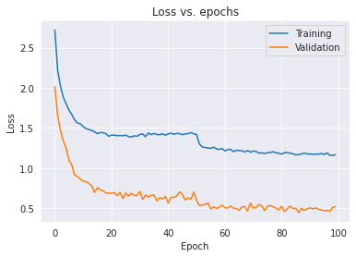

Observations:

1. The validation accuracy was consistently higher than the training accuracy
2. We found about 395+ words that are part of the corpus of our dataset not present in BERT Vocab. A sample list is below:

Subsystem, rudimentary, telephony, reselect, reallocate, stoppage, unresolved, magenta, intercom, pax, wallpaper, projector, charger, legit, wird, revisit, tort, populate, disconnection, deactivation, unrestricted, presume, airway, scannable, misconfiguration, salesperson, headset, extrude, kiosk, resale, mailbox

We think this is one of the reasons why the BERT accuracy could not cross the 80s range.

## GPT2 initial run:

Please refer to notebook: GPT2-Transformers2.ipynb

### **BERT vs GPT2**

The GPT-2 is built using transformer decoder blocks. BERT, on the other hand, uses transformer encoder blocks. But one key difference between the two is that GPT2, like traditional language models, outputs one token at a time. Let’s for example prompt a well-trained GPT-2 to recite the first law of robotics:

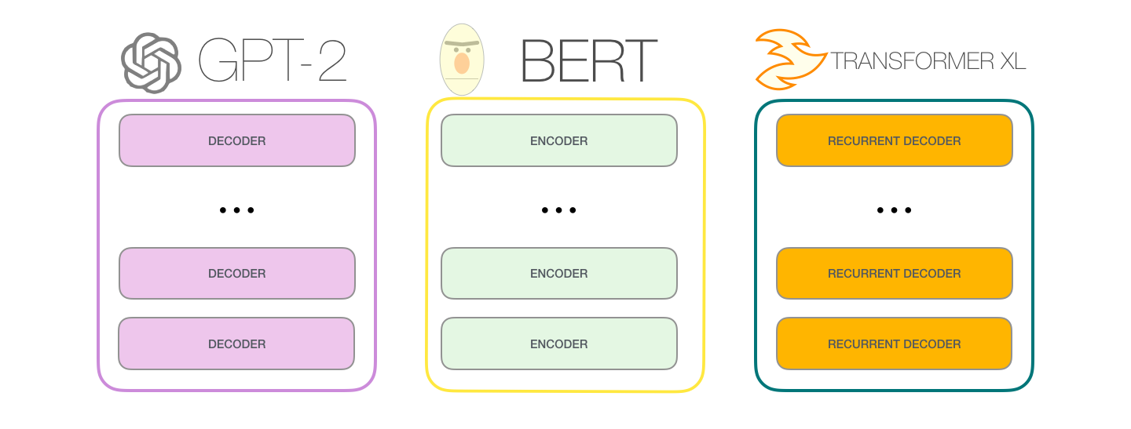

Best Sequence Length:

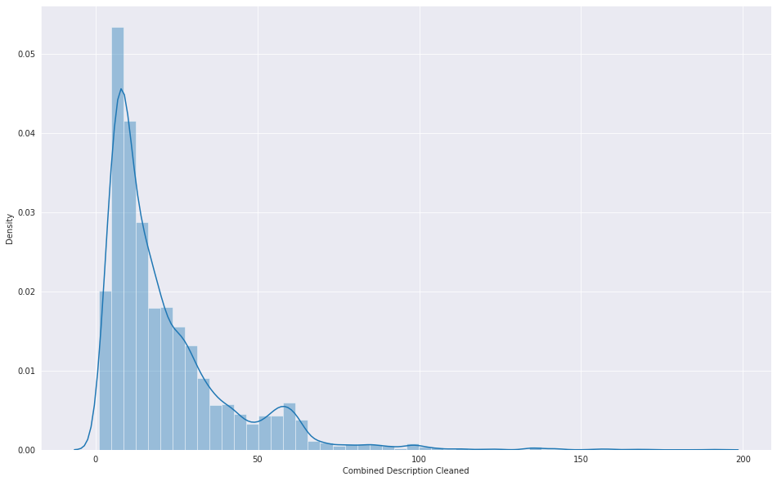

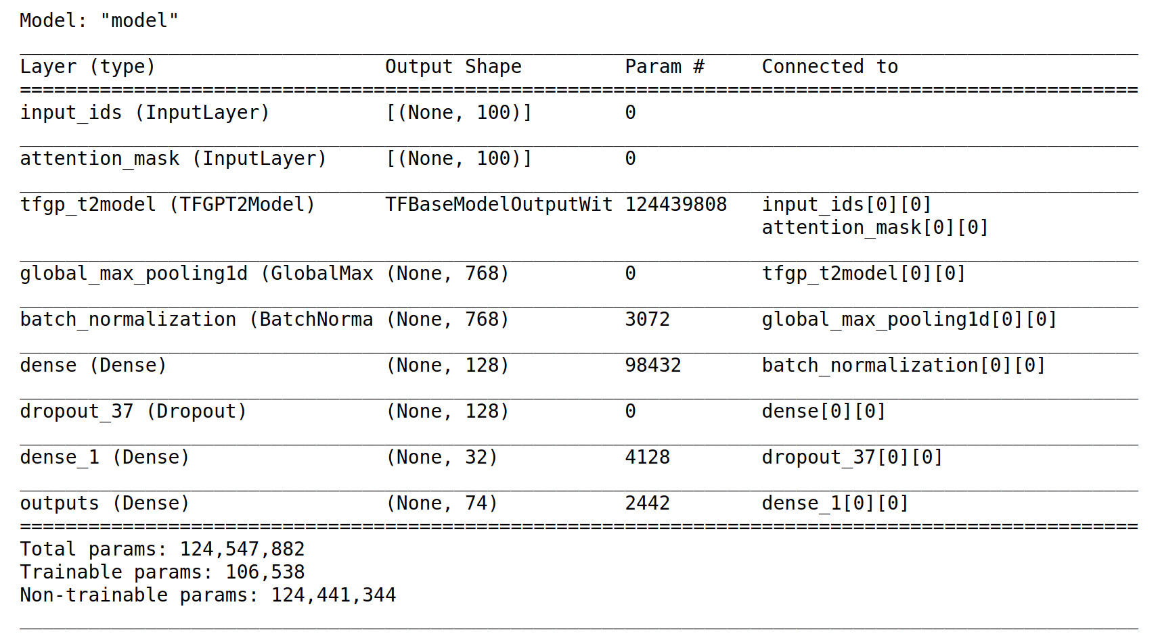

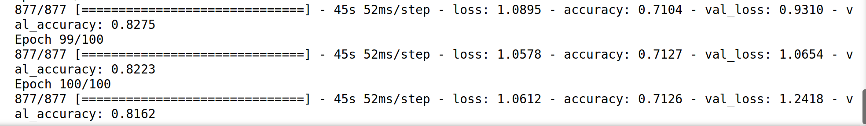

Evaluation Accuracy: 0.814

Evaluation Loss: 1.271

Mean Accuracy for the validation dataset:

0.7966688188910485

Mean Loss for the validation dataset:

1.00599816262722

Mean Accuracy for the training dataset:

0.6913536873459816

Mean Loss for the training dataset:

1.114402573108673

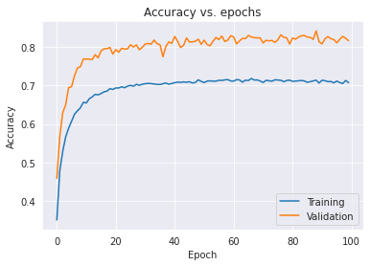

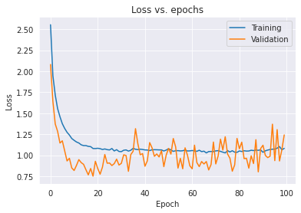

## 

## GPT2 with Hyperparams:

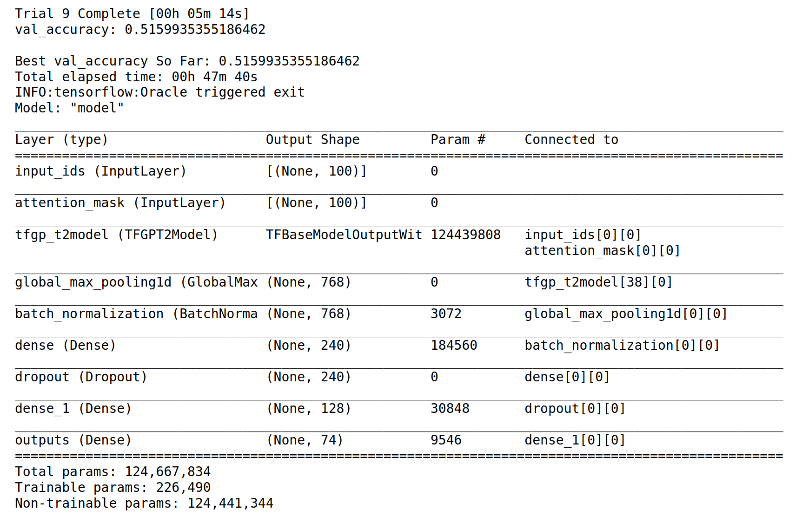

The hyperparameter search is complete. The best parameters are:

first densely-connected layer is 240

the optimal learning rate for the optimizer is 0.0001

the dropout unit is 0.1

the momentum us 0.4

the second densely-connected layer is 128

the batch size is 128

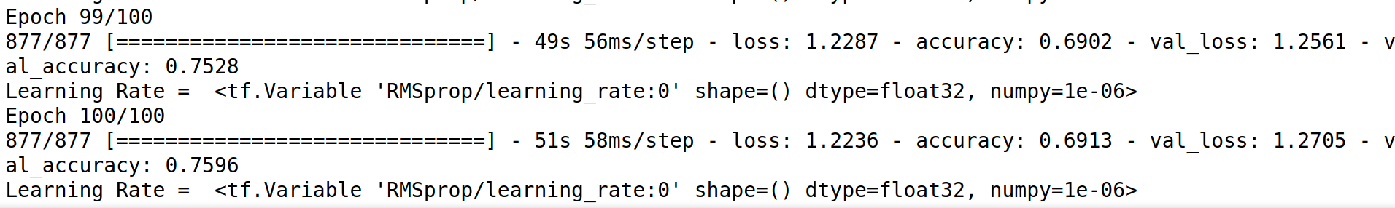

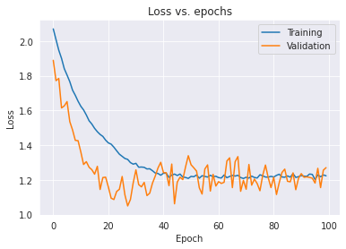

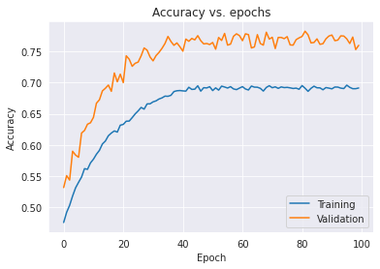

Mean Accuracy for the validation dataset:

0.7376090431213379

Mean Loss for the validation dataset:

1.2496958827972413

Mean Accuracy for the training dataset:

0.6613184145092964

Mean Loss for the training dataset:

1.3292483127117156

Evaluation Accuracy: 0.767

Evaluation Loss: 1.279

## Explore approach for Production Implementation for Real-time calls to an API that can return the Group number the ticket is assigned to.

While we did not have the time to do the implementation, we do want to spend a few minutes on how this model can be invoked in production after training to assign the ticket to the right group.

There are 3 major steps :

Initial Training:

1. Model Training: Using one of the models built from scratch like the CNN or the BiLSTM, or using GPT2 and BERT pretrained models, our objective is to achieve a validation accuracy of above 95%.

Daily Fine Tuning

1. Then this model will be fed with new data in batch mode every night . This can be new tickets collected during the course of that business day. The objective is for the model to update itself based on new information.

Real-time API to call the model.predict

1. At this point, the model is ready to make real-time predictions. We will expose the model.predict as a REST Method behind an API Gateway. The API Gateway will perform the AAA functions (Authentication, Authorization & Audit). Once the call is vetted, the API Gateway will pass on the call to the Application Server that will have the implementation logic. We suggest using an Application Framework like FLASK in Python to implement the model.predict method. Prior to calling this method, the application will need to convert the input string to the appropriate vector (like word2vec, doc2vec, etc). After the prediction, the data is converted back to string and returned back to the caller as a string - GRP_, GRP_2, etc.

## Closing Reflections

The table below shows some of the most significant Model Results:

As show in the green highlighted rows - we were able to increase the Validation accuracy results on the simple CNN using merged vectors (bi-gram, trigram, four-gram) compared to Milistone-1

As shown in the yellow highlighted rows for BiLSTM - we were able to get the margin between validation & Training accuracy to under 3% .

|  |  |  |  |  |  |  |
| --- | --- | --- | --- | --- | --- | --- |
| **Model** | **Validation Acc** | **Training Acc** | **Val Loss** | **Training Loss** | **Ref Page** | **Notebook** |
| Simple CNN with multi-gram Feature Engg & Hyper Param Tuning | 93.29 | 90.84 | 0.44 | 0.32 | 21 | capstone_nlp_FeatureEngg_Part4_cnn_w2v |
| Attention Encoder-Decoder with Hyper Param | 90.07 | 96.56 | 0.44 | 0.08 | 23 | Attention_hyp |
| Bi-LSTM with GloVe and Bayesian Hyper Param tuning | 91.16 | 93.6 | 0.34 | 0.21 | 27 | capstone-nlp-DL-GlOve-BILSTM.ipynb |
| BERT | 86 | 69 | 0.52 | 1.16 | 33 | Bert-Transformers.ipynb |
| GPT-2 | 81.62 | 71.26 | 1.24 | 1.06 | 36 | GPT2-Transformers2.ipynb |
| Simple CNN (Milestone-1) | 92.91 | 84.29 | 0.59 | 0.22 | 60 | capstone-nlp-DL-GlOve.ipynb |
| Bi-LSTM (Milestone-1) | 91.7 | 95.6 | 0.31 | 0.12 | 48 | capstone-nlp-DL-Model-initial-run..ipynb |

We think any of the above models can be used to further fine-tune for Production.

#### Limitations

The most significant limitation we encountered that may have prevented us in achieving better validation accuracy results is the lack of variation in the data . This can be seen in the difference in accuracy between unaugment dataset and the augmented dataset - but we think even the augment dataset (about 31000 records) is not enough. In production, using the different techniques we have shown in this project, the dataset volume needs to be significantly increased to upwards of 100,000 records.

Meta-Learning:

One other technique that can be used is the Meta learning technique in Production. In this technique, the model continues to learn incrementally based on tickets that get created every day .

### Implications

Using the meta-learning technique and using stacking or voting classifiers, our suggestion would be to use at least 2 of the top Machine Learning Models plus 2 of the Deep Learning Models in production actual prediction.

### Comparison to Benchmark

At the beginning of this project we had set this goal:

Create various Machine Learning Models that can help classify incidents and assign them to the right Functional Group. Our objective is to create NLP models that can predict with at least 80% accuracy.

As the table above shows, we have achieved this goal - all the top models have an accuracy of 80% or higher.

### What have you learnt from the process?

1. Quality Data is the most significant input to model building. This along with good data augmentation techniques improve the accuracy of models significantly.
2. Machine Learning Models also provide impressive results and should NOT be ignored .

### ---------------------------------------The above concludes Milestone-2-------------------------------------------

# Initial Run of the Machine Learning & Deep Learning Models :

***Please note: This section was presented for Milestone - 1 : repeated here for continuation purposes.***

## Deciding Models and Model Building

The dataset indicates a Multi-Classification problem with the 74 for labels. Our initial thinking is these models will be applicable in this class of problem.

We used the dataset after Augmentation for running the Machine Learning models. The dataset name is input_data_after_data_for_ml__with_augmentation_knn_round2.csv

We did these steps to prepare the data for feeding into the ML algorithms:

1. We applied the Label Encoder on the labels.
2. For the Features, we used the Count Vectorizer and did a fit transform
3. We applied the Tfidf Transformer to create a matrix of Tf-idf features.
4. We used the sklearn train test split to do a 80:20 split of the Training and Test data.

#### Machine Learning Models:

*For more details on the Machine Learning Models, please review this notebook:* ***capstone-nlp-ML-Model-initial-run.ipynb***

1. Logistic Regression: Logistic regression is one of the most simple Machine Learning models. They are easy to understand, interpretable, and can give pretty good results. Every practitioner using Logistic Regression out there must know about the Log-Odds which is the main concept behind this learning algorithm. The Logistic regression is very much interpretable considering the business needs and explanation regarding how the model works concerning different independent variables used in the model.

**Parameters we used for Logistic Regression:**

solver='lbfgs', max_iter=1000, multi_class='multinomial'

For multiclass problems, ‘lbfgs’ handlesmultinomial loss

For ‘multinomial’ the loss minimised is the multinomial loss fit across the entire probability distribution, *even when the data is binary*.

**Results from Logistic Regression:**



1. Support Vector Machines - *SVM is a sparse technique*. Like nonparametric methods, SVM requires that all the training data be available, that is, stored in memory during the training phase, when the parameters of the SVM model are learned. However, once the model parameters are identified, SVM depends only on a subset of these training instances, called *support vectors*, for future prediction. Support vectors define the margins of the hyperplanes.

**Parameters we used for SVC:**

We first used the GridSearchCV to find the best parameters, Some Parameters we are trying the find the ideal values for:

* C is used during the training phase and says how much outliers are taken into account in calculating Support Vectors
* gamma determines the radius of the area of influence of the support vectors if it is too large, the radius of the area of influence of the support vectors only includes the support vector itself and no amount of regularization with C will be able to prevent overfitting. When gamma is very small, the model is too constrained and cannot capture the complexity or “shape” of the data.
* kernel parameter selects the type of hyperplane used to separate the data.
* We will let the Hypersearch determine the best kernel to use among
  + rbf : The RBF kernel is a stationary kernel. It is also known as the “squared exponential” kernel.
  + poly : A polynomial kernel is a more generalized form of the linear kernel. The polynomial kernel can distinguish curved or nonlinear input space. The polynomial and RBF are especially useful when the data-points are not linearly separable.
  + sigmoid: The Sigmoid Kernel comes from the Neural Networks field, where the bipolar sigmoid function is often used as an activation function for artificial neurons
* probability: We will choose between True & False

**Results from SVC:**

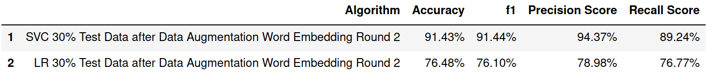

1. K Nearest Neighbors (KNN) - KNN is another useful algorithm for Multi classification problems. The KNN algorithm assumes that similar things exist in close proximity. In other words, similar things are near to each other . As we note later, we used this algorithm also to efficiently find synonyms of the key words in our corpus.

**Parameters we used for KNN:**

We first ran the KNN to find the optimal k between 1 and 20. We then applied the KNN Classifier with the optimal k value found .

**Results from SVC:**

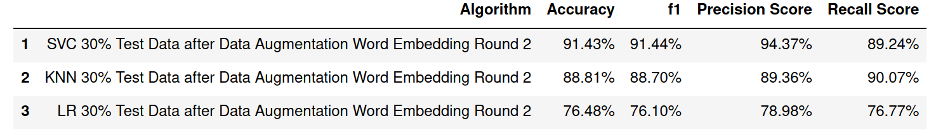

1. Ensembles
   1. Bagging Classifier: Bagging uses a simple approach that shows up in statistical analyses again and again — improve the estimate of one by combining the estimates of many. Bagging constructs n classification trees using bootstrap sampling of the training data and then combines their predictions to produce a final meta-prediction.

**Parameters used for Bagging Classifier:**

n_estimators=10, max_samples= .7, bootstrap=True

**Results from Bagging Classifier:**

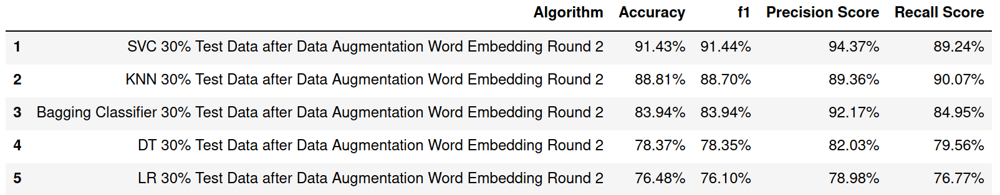

* 1. Decision Tree: Decision tree builds classification or regression models in the form of a tree structure. It breaks down a dataset into smaller and smaller subsets while at the same time an associated decision tree is incrementally developed. The final result is a tree with **decision nodes** and **leaf nodes**. A decision node (e.g., Outlook) has two or more branches (e.g., Sunny, Overcast and Rainy). Leaf node (e.g., Play) represents a classification or decision. The topmost decision node in a tree which corresponds to the best predictor called **root node**. Decision trees can handle both categorical and numerical data.

**Parameters used for Decision Tree:**

We built our model using the DecisionTreeClassifier function. Using default 'gini' criteria to split. Another option is 'entropy'.

Gini: measures how often a randomly chosen element from the set would be incorrectly labeled.

Entropy: It is used to measure the impurity or randomness of a dataset

**Results from Decision Tree:**

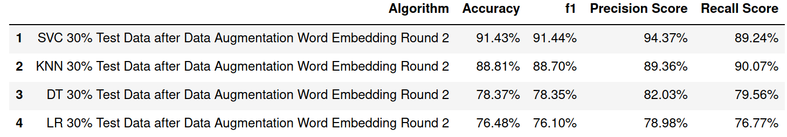

* 1. XGBoost: The XGBoost algorithm is effective for a wide range of regression and classification predictive modeling problems. It is an efficient implementation of the stochastic gradient boosting algorithm and offers a range of hyperparameters that give fine-grained control over the model training procedure. Although the algorithm performs well in general, even on imbalanced classification datasets, it offers a way to tune the training algorithm to pay more attention to misclassification of the minority class for datasets with a skewed class distribution

**Parameters used for XGB:**

We used GridSearchCV to look for best parameters for XGB. These are some of the parameters fed into the GridSearchCV algorithm:

* min_child_weight : Minimum sum of instance weight (hessian) needed in a child.
* gamma: Minimum loss reduction required to make a further partition on a leaf node of the tree. The larger gamma is, the more conservative the algorithm will be.
* subsample: Subsample ratio of the training instances. Setting it to 0.5 means that XGBoost would randomly sample half of the training data prior to growing trees. and this will prevent overfitting.
* colsample_bytree: is the subsample ratio of columns when constructing each tree. Subsampling occurs once for every tree constructed.

**Results from XGB:**

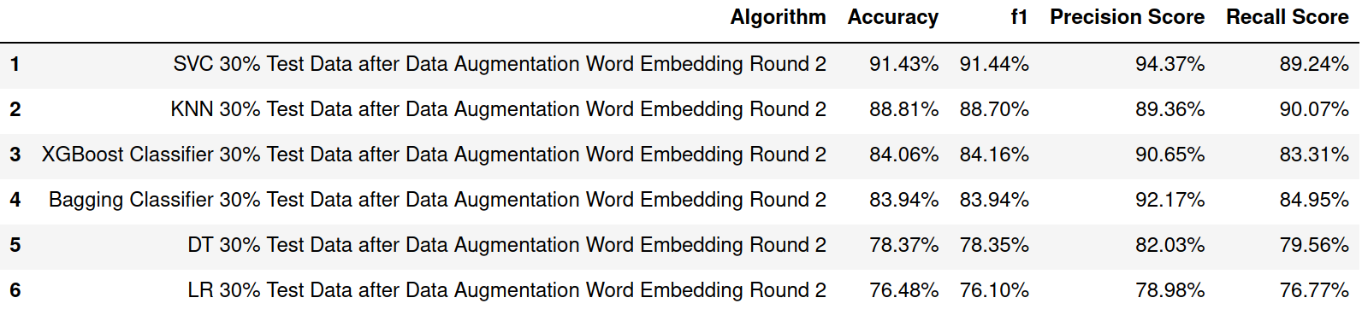

1. Stacker:

We also tried with Stacker Classifier with layer 1 and layer 2 estimators. In Layer 1 we used these estimators: SVC, Logistic Regression, Decision Tree. Final Estimator used was XGB.

Layer 2 - we used these estimators: Bagging Classifier, Logistic Regression, XG Boost. Layer 2 served as the final estimator for Layer 1.

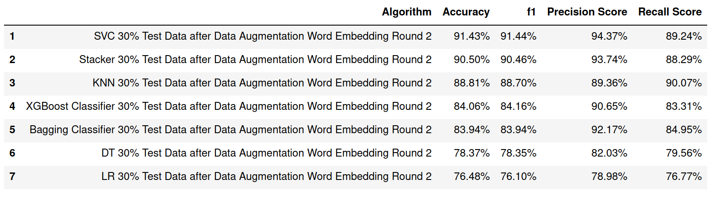

#### Deep Learning Models

*For more details on the Deep Learning Models, please review these notebooks:*

***capstone-nlp-DL-Model-initial-run.ipynb***

***capstone-nlp-DL-GlOve.ipynb***

So far we have implemented the following models for unaugmented data, level1 augmented data and level2 augmented data.

**Deep learning models**

We have implemented the following 7 deep learning models

1) **LSTM**-

**cp_dl.ipynb(without hyperparameter tuning)**

cp_dl _hyp.ipynb(with hyperparameter tuning)

Long Short-Term Memory (LSTM) networks are a type of recurrent neural network capable of learning order dependence in sequence prediction problems.This is a behavior required in complex problem domains like machine translation, speech recognition, and more.A common LSTM unit is composed of a cell, an input gate, an output gate and a forget gate. The cell remembers values over arbitrary time intervals and the three gates regulate the flow of information into and out of the cell.LSTM is the response to RNN’s Vanishing Gradient Problem.The intuition behind LSTM is that the machine will learn the importance of previous words, so that we will not lose information from older hidden states.

Advantages of LSTM

*Non-decaying error backpropagation.

*For long time lag problems, LSTM can handle noise and continuous values.

*No parameter fine tuning.

*Memory for long time periods

2) **GRU**-

cp_dl.ipynb(without hyperparameter tuning)

cp_dl _hyp.ipynb(with hyperparameter tuning)

GRU stands for Gated Recurrent Units.They are also provided with a gated mechanism to effectively and adaptively capture dependencies of different time scales. They have an update gate and a reset gate. The former is responsible for selecting what piece of knowledge is to be carried forward, whereas the latter lies in between two successive recurrent units and decides how much information needs to be forgotten.

Advantages of GRU

*Shorter training time

*Requires fewer data points to capture the properties of the data

3) **Bidirectional LSTM**-

**cp_dl.ipynb(without hyperparameter tuning)**

cp_dl _hyp.ipynb(with hyperparameter tuning)

Bidirectional Lstm are really just putting two independent Lstms together. This structure allows the networks to have both backward and forward information about the sequence at every time step.Using bidirectional will run your inputs in two ways, one from past to future and one from future to past and what differs this approach from unidirectional is that in the LSTM that runs backward you preserve information from the future and using the two hidden states combined you are able in any point in time to preserve information from both past and future.

Advantage of Bidirectional LSTM

*it understands the context better.

4)**Bidirectional GRU**

**cp_dl.ipynb(without hyperparameter tuning)**

cp_dl _hyp.ipynb(with hyperparameter tuning)

Bidirectional GRU’s are a type of bidirectional recurrent neural networks with only the input and forget gates. It allows for the use of information from both previous time steps and later time steps to make predictions about the current state

Advantage of Bidirectional GRU

*it understands the context better.

5)**Encoder Decoder(without attention mechanism):**

**Transformer_no_att_no_hyp.ipynb(without hyperparameter tuning)**

**Transformer_no_att_hyp.ipynb(with hyperparameter tuning)**

A sequence to sequence model lies behind numerous systems which you face on a daily basis. For instance, seq2seq model powers applications like Google Translate, voice-enabled devices and online chatbots.The model consists of 3 parts: encoder, intermediate (encoder) vector and decoder.

Encoder

* A stack of several recurrent units (LSTM or GRU cells for better performance) where each accepts a single element of the input sequence, collects information for that element and propagates it forward.

Encoder Vector

* This is the final hidden state produced from the encoder part of the model.
* This vector aims to encapsulate the information for all input elements in order to help the decoder make accurate predictions.
* It acts as the initial hidden state of the decoder part of the model.

Decoder

* A stack of several recurrent units where each predicts an output *y_t* at a time step *t*.
* Each recurrent unit accepts a hidden state from the previous unit and produces an output as well as its own hidden state.

6) **Sequence to sequence model with attention mechanism**

**Attention_no_hyp.ipynb(without hyperparameter tuning)**

**Attention_hyp.ipynb(with hyperparameter tuning)**

: Two variations of the model have been implemented

**a)Encoder with attention mechanism**

**b)Encoder Decoder with attention mechanism**

The main drawback of this sequence to sequence model is evident. If the encoder makes a bad summary, the prediction will also be bad. And indeed it has been observed that the encoder creates a bad summary when it tries to understand longer sentences. It is called the long-range dependency problem of RNN/LSTMs.RNNs cannot remember longer sentences and sequences due to the vanishing/exploding gradient problem. It can remember the parts which it has just seen. The performance of the encoder-decoder network degrades rapidly as the length of the input sentence increases.

Although an LSTM is supposed to capture the long-range dependency better than the RNN, it tends to become forgetful in specific cases.

Attention

The basic idea: each time the model predicts an output word, it only uses parts of an input where the most relevant information is concentrated instead of an entire sentence. In other words, it only pays attention to some input words. .Encoder works as usual, and the difference is only on the decoder’s part. As you can see from a picture, the decoder’s hidden state is computed with a context vector, the previous output and the previous hidden state. But now we use not a single context vector c, but a separate context vector for each target word.These context vectors are computed as a weighted sum of *annotations* generated by the encoder. The weight of each annotation is computed by an *alignment model* which scores how well the inputs and the output match

**Implementations**

There are 2 variations of each model one without hyperparameter tuning and one with hyperparameter tuning. The hyperparameter tuning was done for batch size, and learning rate. Thus we have a total of 42 models. The accuracy scores are shown in the table below

|  |  |  |  |  |  |  |
| --- | --- | --- | --- | --- | --- | --- |
| **Model** | **Unaug**  **Acc/Train Acc** | **Aug1**  **Acc/Train Acc** | **Aug2**  **Acc/Train Acc** | **Unaug**  **Acc/Train Acc with Hyp** | **Aug1**  **Acc/Train Acc with Hyp** | **Aug2**  **Acc/Train Acc with Hyp** |
| **Lstm** | **58.5/**  **65.0** | **76.3/**  **83.6** | **86.2/**  **88.1** | **59.0/**  **67.5** | **78.3/**  **85.3** | **87.9/**  **91.2** |
| **Bilstm** | **58.4/**  **71.4** | **76.4/**  **82.3** | **85.7/**  **86.4** | **57.9/**  **71.0** | **80.5/**  **87.9** | **88.7/**  **91.7** |
| **Gru** | **58.0/**  **71.9** | **80.8/**  **88.9** | **87.6/**  **89.1** | **58.8/**  **74.2** | **82.6/**  **89.8** | **89.2/**  **91.2** |
| **BiGru** | **58.5/**  **74.5** | **79.1/**  **82.9** | **88.6/**  **89.3** | **58.0/**  **73.5** | **82.9/**  **89.8** | **90.7/**  **93.6** |
| **\*Trans_no_att** | **58.7/ 66.4** | **72.8/**  **79.5** | **84.8/**  **88.3** | **60.0/**  **69.0** | **75.9/**  **84.4** | **84.1/**  **88.2** |
| **Enc_att** | **57.3/**  **70.8** | **73.8/**  **82.1** | **85.6/**  **87.8** | **54.7/**  **56.7** | **70.2/**  **80.9** | **88.6/**  **93.8** |
| **\*Trans_att** | **57.3/**  **62.4** | **78.8/**  **86.2** | **87.4/**  **87.8** | **58.1/**  **68.2** | **80.0/**  **92.0** | **90.0/**  **96.0** |

*Trans-Transformer(Encoder-Decoder)

**Table1:Accuracy Scores**

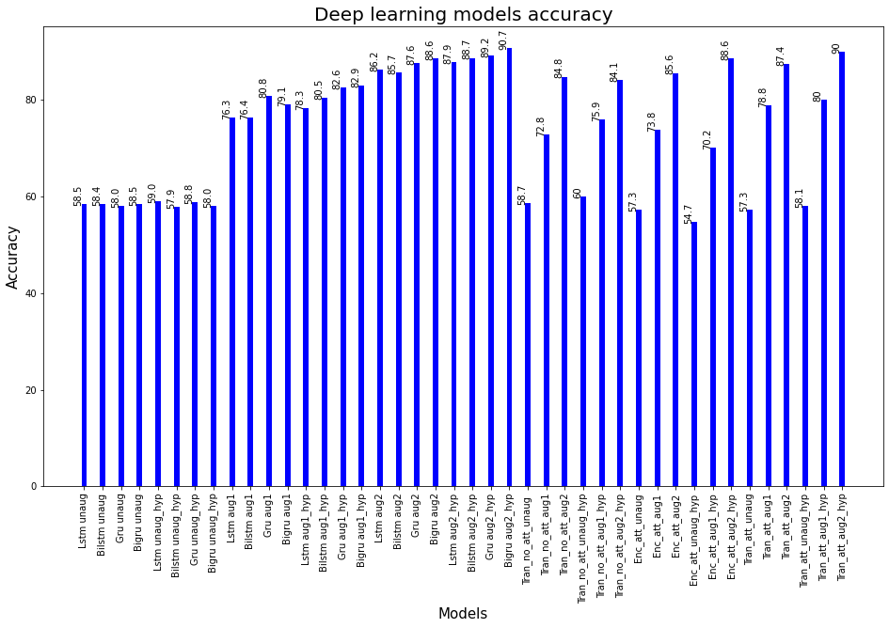

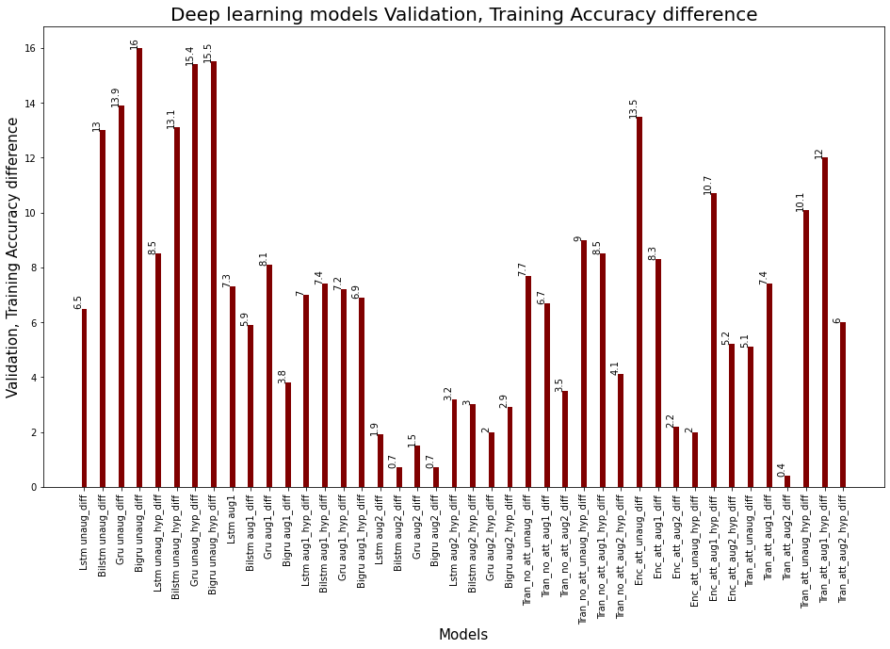

**Conclusions**

It can be seen that augmentation of the data gives a substantial improvement in the accuracy score and hyperparameter tuning gives a marginal improvement in most cases. The Bidirectional GRU using level 2 augmented data gives the highest accuracy of 90.7%,followed by Transformer with attention with an accuracy of 90%.The level 2 augmented data with hyperparameter tuned models have an accuracy improvement of at least over 25% in all models and these models have an **accuracy in the range 84.1 to 90.7.**Transformer models are more suited for language translation but were used to compare accuracies.They were designed using the least number of dense layers(64) as anything more was very resource intensive especially when the repeatvector layers were increased .The training of transformer alone took around 3 days on a Nvidia Gtx 1650 Gpu.

The 2nd plot shows the difference in training and validation accuracy.The unaugmented models underfit with a difference between training and validation accuracy in the range 6.5% to 15.5.But once the data is augmented the models have more data to work with and hence the difference in accuracy reduces.**Transformer with attention and level 2 augmentation and hyperparameter tuning has the least difference in accuracy of 0.4**  followed by the Gru and and Bilstm with no hyperparameter tuning both of which have an accuracy difference of 0.7

#### Deep Learning Model Training with GloVe: Global Vectors for Word Representation.

For details please refer to notebook capstone-nlp-DL-GlOve.ipynb

GloVe is an unsupervised learning algorithm for obtaining vector representations for words. Training is performed on aggregated global word-word co-occurrence statistics from a corpus, and the resulting representations showcase interesting linear substructures of the word vector space.

We tried these Deep Learning Models after processing the dataset to use the GloVe Vectors . The glove dataset used was glove.840B.300d.txt.

We first used the sklearn train test split to split the dataset. We converted the dataset to GloVe embedded matrix.

Parameters used:

* EMBEDDING_FILE = 'embeddings/glove.840B.300d/glove.840B.300d.txt'
* MAX_SEQUENCE_LENGTH = 500
* EMBEDDING_DIM=300
* MAX_NB_WORDS=75000
* BATCH_SIZE = 32

The models trained, parameters used and results are below:

**CNN:**

**Optimizer used: tf.keras.optimizers.SGD(lr=0.001, momentum=0.9)**

Model: "model"

__________________________________________________________________________________________________

Layer (type) Output Shape Param # Connected to

==================================================================================================

input_1 (InputLayer) [(None, 500)] 0

__________________________________________________________________________________________________

embedding (Embedding) (None, 500, 300) 1353000 input_1[0][0]

__________________________________________________________________________________________________

conv1d (Conv1D) (None, 499, 128) 76928 embedding[0][0]

__________________________________________________________________________________________________

conv1d_1 (Conv1D) (None, 498, 128) 115328 embedding[0][0]

__________________________________________________________________________________________________

conv1d_2 (Conv1D) (None, 497, 128) 153728 embedding[0][0]

__________________________________________________________________________________________________

conv1d_3 (Conv1D) (None, 496, 128) 192128 embedding[0][0]

__________________________________________________________________________________________________

conv1d_4 (Conv1D) (None, 495, 128) 230528 embedding[0][0]

__________________________________________________________________________________________________

max_pooling1d (MaxPooling1D) (None, 99, 128) 0 conv1d[0][0]

__________________________________________________________________________________________________

max_pooling1d_1 (MaxPooling1D) (None, 99, 128) 0 conv1d_1[0][0]

__________________________________________________________________________________________________

max_pooling1d_2 (MaxPooling1D) (None, 99, 128) 0 conv1d_2[0][0]

__________________________________________________________________________________________________

max_pooling1d_3 (MaxPooling1D) (None, 99, 128) 0 conv1d_3[0][0]

__________________________________________________________________________________________________

max_pooling1d_4 (MaxPooling1D) (None, 99, 128) 0 conv1d_4[0][0]

__________________________________________________________________________________________________

concatenate (Concatenate) (None, 495, 128) 0 max_pooling1d[0][0]

max_pooling1d_1[0][0]

max_pooling1d_2[0][0]

max_pooling1d_3[0][0]

max_pooling1d_4[0][0]

__________________________________________________________________________________________________

conv1d_5 (Conv1D) (None, 491, 128) 82048 concatenate[0][0]

__________________________________________________________________________________________________

dropout (Dropout) (None, 491, 128) 0 conv1d_5[0][0]

__________________________________________________________________________________________________

batch_normalization (BatchNorma (None, 491, 128) 512 dropout[0][0]

__________________________________________________________________________________________________

max_pooling1d_5 (MaxPooling1D) (None, 98, 128) 0 batch_normalization[0][0]

__________________________________________________________________________________________________

conv1d_6 (Conv1D) (None, 94, 128) 82048 max_pooling1d_5[0][0]

__________________________________________________________________________________________________

dropout_1 (Dropout) (None, 94, 128) 0 conv1d_6[0][0]

__________________________________________________________________________________________________

batch_normalization_1 (BatchNor (None, 94, 128) 512 dropout_1[0][0]

__________________________________________________________________________________________________

max_pooling1d_6 (MaxPooling1D) (None, 3, 128) 0 batch_normalization_1[0][0]

__________________________________________________________________________________________________

flatten (Flatten) (None, 384) 0 max_pooling1d_6[0][0]

__________________________________________________________________________________________________

dense (Dense) (None, 1024) 394240 flatten[0][0]

__________________________________________________________________________________________________

dropout_2 (Dropout) (None, 1024) 0 dense[0][0]

__________________________________________________________________________________________________

dense_1 (Dense) (None, 512) 524800 dropout_2[0][0]

__________________________________________________________________________________________________

dropout_3 (Dropout) (None, 512) 0 dense_1[0][0]

__________________________________________________________________________________________________

dense_2 (Dense) (None, 74) 37962 dropout_3[0][0]

==================================================================================================

Total params: 3,243,762

Trainable params: 3,243,250

Non-trainable params: 512

**Results for CNN:**

Orange **- training, blue validation**

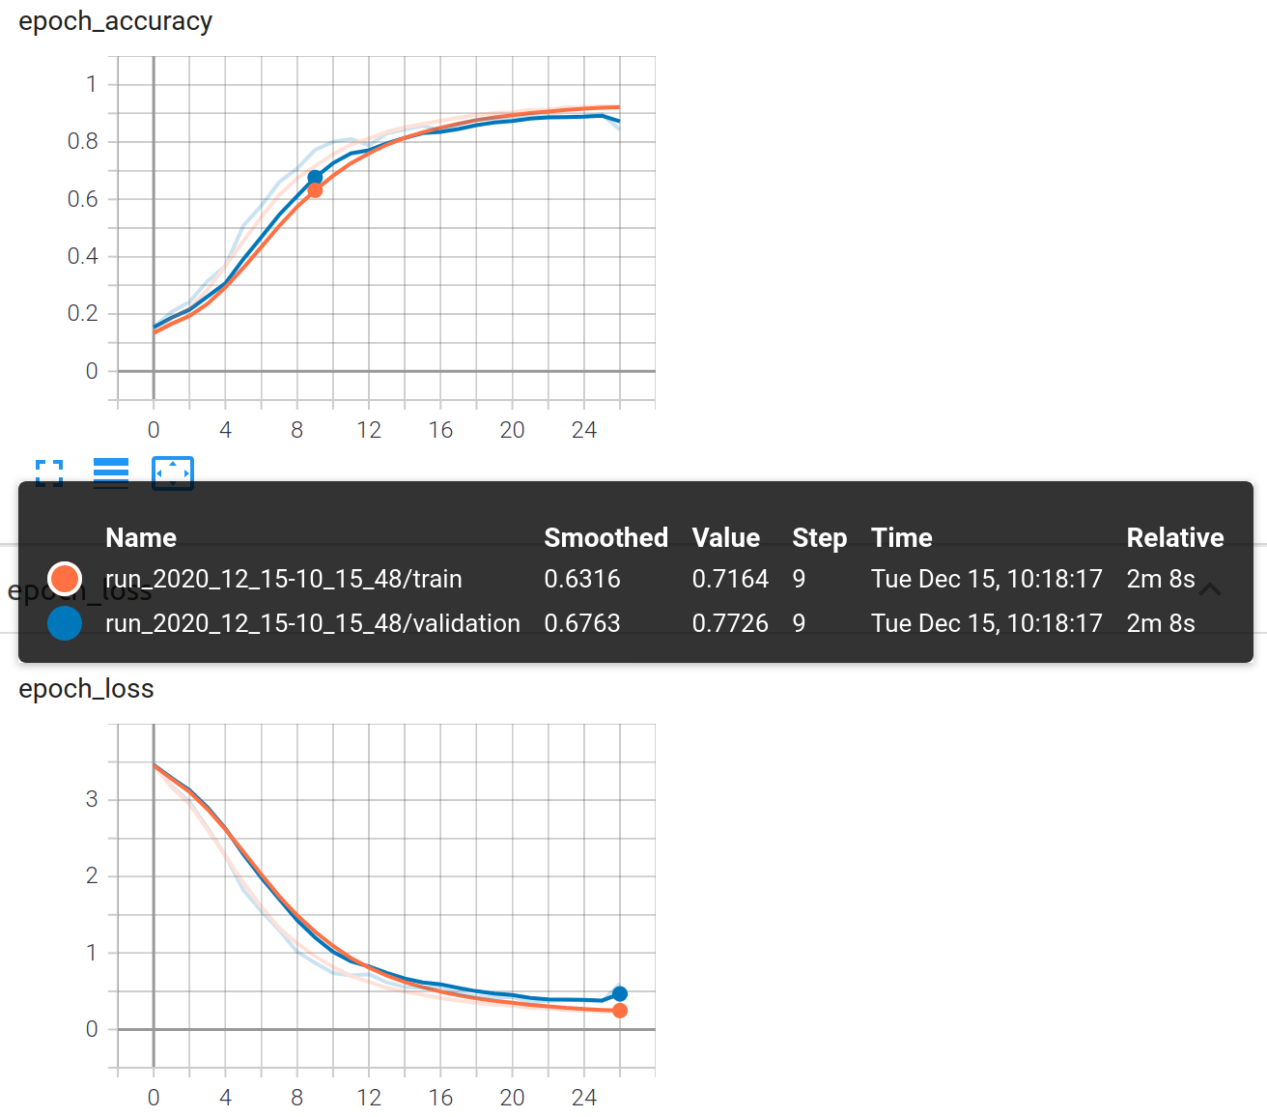

Unsmoothed plots of Accuracy & Loss for CNN:

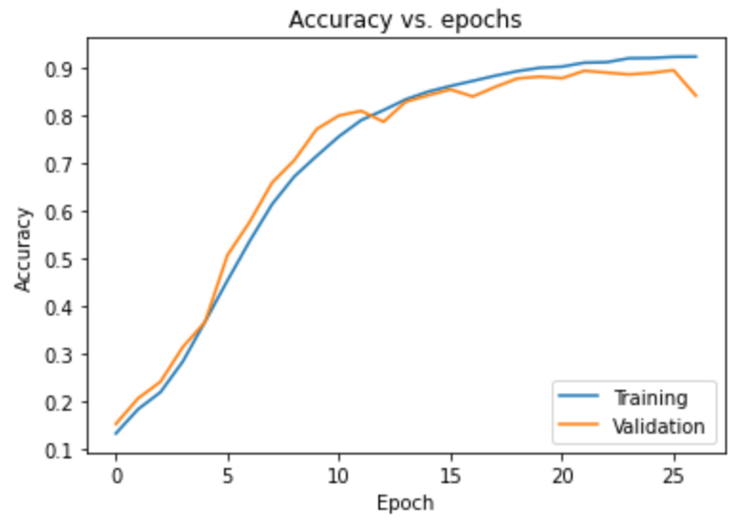

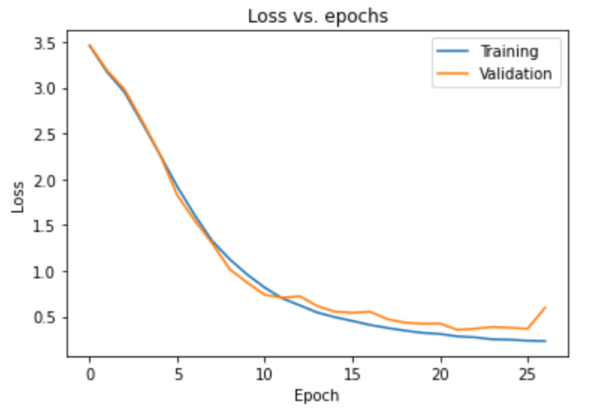

Epoch 00025: saving model to checkpoints_best_only/checkpoint

Epoch 26/100

779/779 [==============================] - 15s 20ms/step - loss: 0.2281 - accuracy: 0.9276 - val_loss: 0.3667 - val_accuracy: 0.8964

Results at the end of the 27th epoch after which early stopping kicked in

Epoch 00026: saving model to checkpoints_best_only/checkpoint

Epoch 27/100

779/779 [==============================] - 15s 19ms/step - loss: 0.2239 - **accuracy: 0.9291** - **val_loss: 0.5970** - **val_accuracy: 0.8429**

val/train: 2.56

Epoch 00027: saving model to checkpoints_best_only/checkpoint

Epoch 00027: early stopping

Precision: 0.857542

Recall: 0.842942

F1 score: 0.838929

Evaluation Accuracy: 0.843

Evaluation Loss: 0.597

**GRU:**

**Optimizer used: tf.keras.optimizers.SGD(lr=0.001, momentum=0.9)**

GRU Model Summary:

Model: "sequential"

_________________________________________________________________

Layer (type) Output Shape Param #

=================================================================

embedding (Embedding) (None, 500, 300) 1353000

_________________________________________________________________

cu_dnngru (CuDNNGRU) (None, 500, 32) 32064

_________________________________________________________________

dropout (Dropout) (None, 500, 32) 0

_________________________________________________________________

batch_normalization (BatchNo (None, 500, 32) 128

_________________________________________________________________

cu_dnngru_1 (CuDNNGRU) (None, 500, 32) 6336

_________________________________________________________________

dropout_1 (Dropout) (None, 500, 32) 0

_________________________________________________________________

batch_normalization_1 (Batch (None, 500, 32) 128

_________________________________________________________________

cu_dnngru_2 (CuDNNGRU) (None, 500, 32) 6336

_________________________________________________________________

dropout_2 (Dropout) (None, 500, 32) 0

_________________________________________________________________

batch_normalization_2 (Batch (None, 500, 32) 128

_________________________________________________________________

cu_dnngru_3 (CuDNNGRU) (None, 500, 32) 6336

_________________________________________________________________

dropout_3 (Dropout) (None, 500, 32) 0

_________________________________________________________________

batch_normalization_3 (Batch (None, 500, 32) 128

_________________________________________________________________

cu_dnngru_4 (CuDNNGRU) (None, 500, 32) 6336

_________________________________________________________________

dropout_4 (Dropout) (None, 500, 32) 0

_________________________________________________________________

batch_normalization_4 (Batch (None, 500, 32) 128

_________________________________________________________________

cu_dnngru_5 (CuDNNGRU) (None, 500, 32) 6336

_________________________________________________________________

dropout_5 (Dropout) (None, 500, 32) 0

_________________________________________________________________

batch_normalization_5 (Batch (None, 500, 32) 128

_________________________________________________________________

cu_dnngru_6 (CuDNNGRU) (None, 32) 6336

_________________________________________________________________

dropout_6 (Dropout) (None, 32) 0

_________________________________________________________________

batch_normalization_6 (Batch (None, 32) 128

_________________________________________________________________

dense (Dense) (None, 256) 8448

_________________________________________________________________

batch_normalization_7 (Batch (None, 256) 1024

_________________________________________________________________

dense_1 (Dense) (None, 74) 19018

=================================================================

Total params: 1,452,466

Trainable params: 1,451,506

Non-trainable params: 960

Results for GRU:

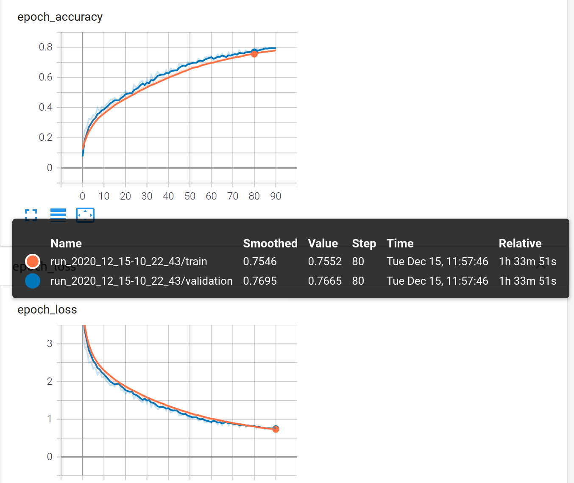

Epoch 00090: saving model to checkpoints_best_only/checkpoint

Epoch 91/100

779/779 [==============================] - 76s 97ms/step - loss: 0.6893 - accuracy: 0.7912 - val_loss: 0.7361 - val_accuracy: 0.7978

val/train: 1.03

Epoch 00091: saving model to checkpoints_best_only/checkpoint

Epoch 00091: early stopping

Evaluation Accuracy: 0.798

Evaluation Loss: 0.736

Mean Accuracy for the validation dataset:

0.6217235459403677

Mean Loss for the validation dataset:

1.3452635348498165

Mean Accuracy for the training dataset:

0.5949455665854307

Mean Loss for the training dataset:

1.4078370489916958

Unsmoothed Plots of Accuracy & Losses:

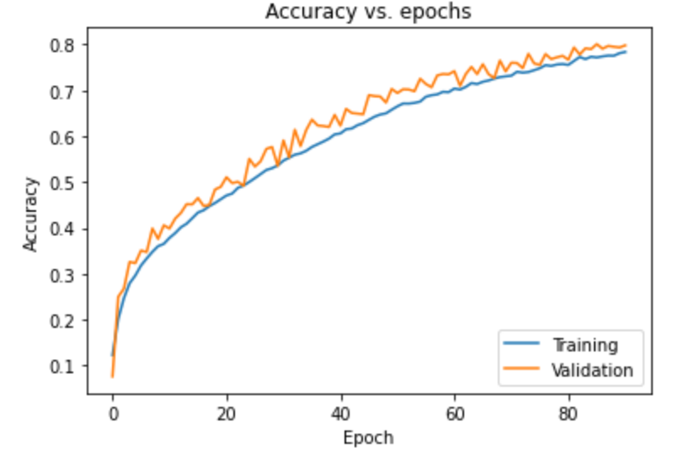

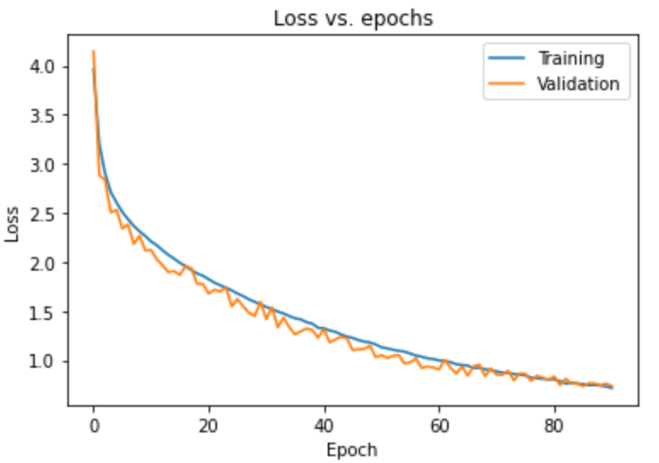

## How to improve your model performance?

Please note : the model runs above incorporate the results from the Data Augmentation techniques outlined below.

As noted earlier, our first model run with Logistic Regression using the preprocessed data could ONLY score 62% accuracy.

It became pretty clear immediately, we had to do something to improve the scores.

We researched on Data Augmentation techniques and some pointers provided by our mentor proved very useful. We researched these techniques:

1. Translation based Data Augmentation - we pick each ticket , translate it into random language and translate it back to English. While this was powerful, the amount of time it took was huge and it did NOT provide the volume of data needed for our scores to make a difference.

For details about translation based Data Augmentation please refer to notebook: capstone-nlp-Data-Augmentation-by-Translation.ipynb

1. Spacy based technique - we used spacy to find synonyms of words. The technique is to substitute random words in the ticket with their synonyms. This again took too much time for spacy to generate synonyms, so we had to abandon it. We think the above provide very good potential, but given the time we had we had to find another technique. For details about translation based Data Augmentation please refer to notebook: capstone-nlp-Data-Augmentation-by-spaCy.ipynb
2. We used KNN to find the synonyms - These are technically not synonyms but the words are very close based on their ‘distance’ from the candidate word for which we are finding the synonym.

Examples:

'reset': ['disable', 'restart', 'manually', 'disconnect'],

'issue': ['problem', 'question', 'concern', 'concerned'],

'unable': ['cannot', 'able', 'failing', 'however'],

'you': ['sure', 'want', 'can', 'know'],

'have': ['they', 'could', 'already', 'would'],

'user': ['login', 'automatically', 'functionality', 'interface'],

'my': ['me', 'myself', 'own', 'got'],

'error': ['incorrect', 'invalid', 'problem', 'exception'],

'access': ['accessible', 'allow', 'provide', 'secure'],

'hello': ['hi', 'hey', 'yes', 'dear'],

'be': ['should', 'being', 'not', 'will'],

'account': ['payment', 'personal', 'same', 'however'],

1. We also used Parts of Speech tagging in a similar way to identify synonyms.

Examples:

'trying': ['try'],

'working': ['work'],

'home': ['house'],

'unlocking': ['unlock'],

'locked': ['lock'],

'getting': ['get'],

'need': ['want'],

'dynamics': ['dynamic'],

'regarding': ['regard'],

'phone': ['telephone'],

'client': ['customer'],

'duplication': ['duplicate'],

'gentle': ['soft'],

'display': ['showing'],

For the detailed code for synonyms using KNN & POS tagging, please refer to the notebook:

capstone-nlp-Data-Augmentation-by-Word-Embeddings.ipynb

Because using KNN technique, we could find multiple synonyms for a word, we settled on using the synonyms from KNN to create Tickets where we subtitied a random word in the ticket with its synonym keeping the label the same.

For example, in the below sample, the word accessible was changed to reachable, so the same meaning is retained yet it helped us create a new ticket for the same group.

|  |  |
| --- | --- |
| **accessible** hand language icon customer number telephone | GRP_3 |
| **reachable** hand language explorer customer number telephone | GRP_3 |

We also excluded the majority group GRP_0 and concentrated on increasing the number of records for the minority groups.

Fig 12 - Distribution before Augmentation

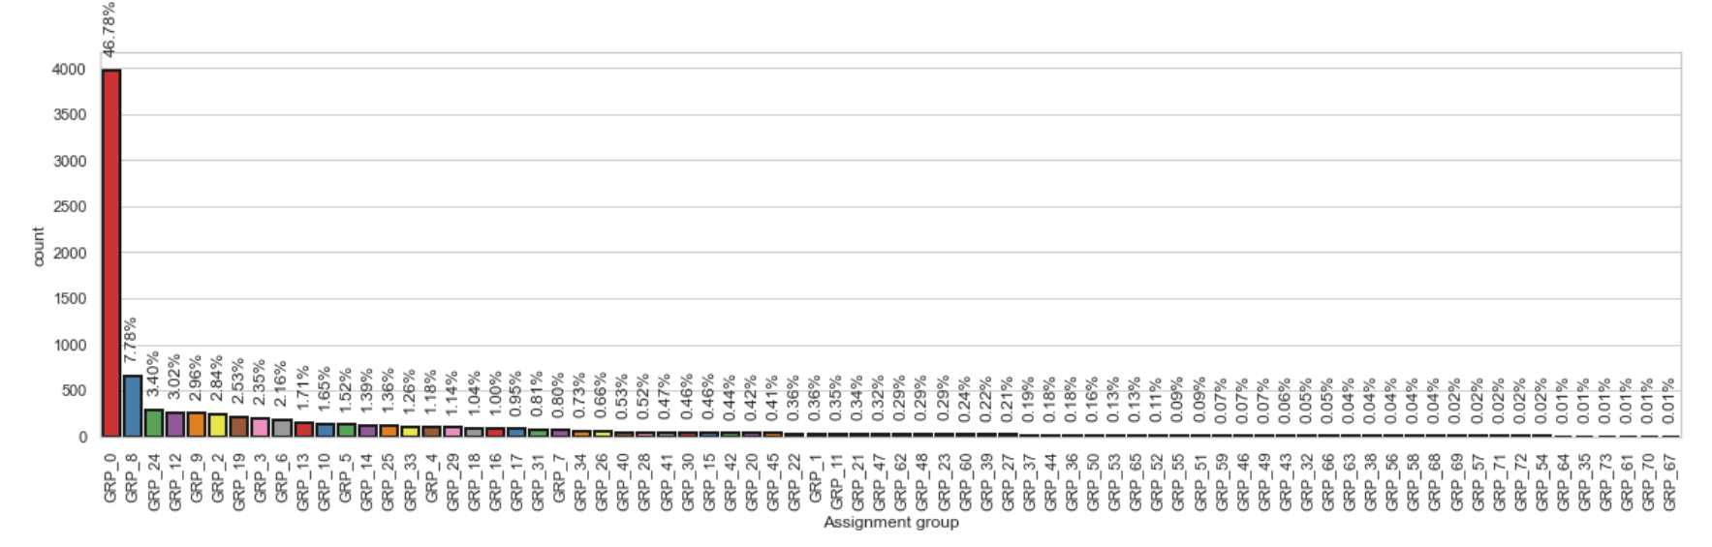

Fig 13 - Distribution after Augmentation

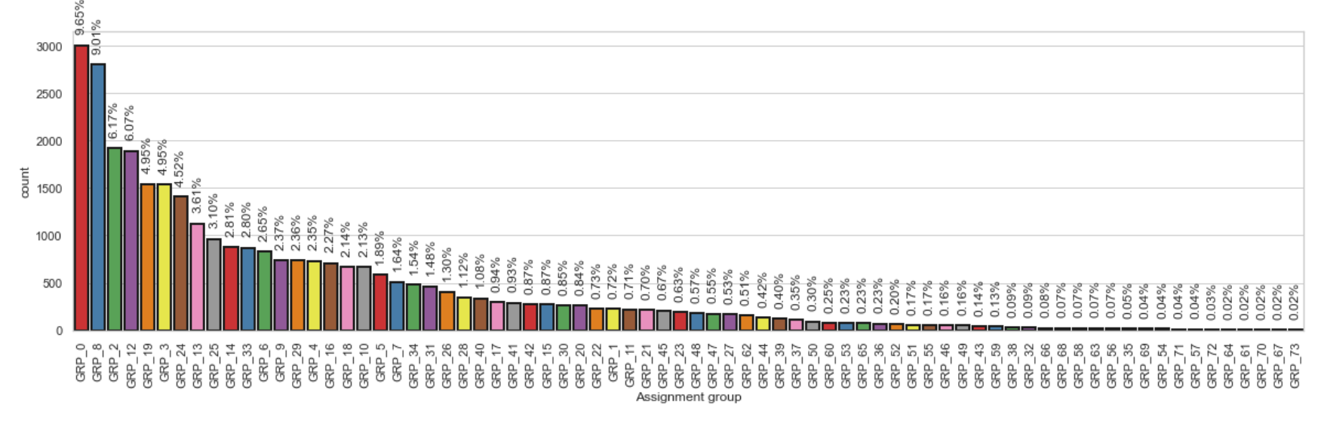As the graphs indicate, we were able to significantly increase the representation of the minority groups. The initial results are promising. A sample classification report below shows that there is test data in every group:

precision recall f1-score support

0 0.63 0.71 0.67 919

1 0.85 0.78 0.81 64

2 0.94 0.88 0.91 193

3 0.96 0.87 0.91 78

4 0.84 0.84 0.84 594

5 0.95 0.93 0.94 327

6 0.91 0.84 0.87 242

7 1.00 0.87 0.93 84

8 0.92 0.93 0.92 224

9 0.99 0.95 0.97 73

10 0.97 0.94 0.96 186

11 0.84 0.84 0.84 447

12 0.86 0.90 0.88 585

13 1.00 0.95 0.97 78

14 0.95 0.93 0.94 61

15 0.99 0.88 0.93 75

16 0.88 0.91 0.89 55

17 0.80 0.90 0.85 433

18 0.92 0.97 0.95 265

19 0.94 0.81 0.87 113

20 0.90 0.84 0.87 45

21 0.96 0.78 0.86 105

22 0.97 0.89 0.93 236

23 0.83 0.86 0.84 469

24 0.94 0.82 0.88 83

25 0.83 0.74 0.78 148

26 1.00 0.80 0.89 10

27 0.92 0.87 0.90 269

28 0.85 0.85 0.85 142

29 1.00 1.00 1.00 2

30 0.89 0.63 0.74 27

31 1.00 0.91 0.96 35

32 1.00 1.00 1.00 10

33 0.67 0.59 0.62 34

34 0.92 0.86 0.89 237

35 0.96 0.93 0.94 97

36 0.96 0.95 0.96 79

37 0.95 0.93 0.94 87

38 1.00 0.92 0.96 13

39 1.00 0.92 0.96 26

40 0.96 0.82 0.89 66

41 1.00 1.00 1.00 16

42 0.69 0.48 0.56 42

43 0.96 0.89 0.93 57

44 1.00 0.92 0.96 12

45 0.62 0.61 0.61 155

46 0.85 0.74 0.79 31

47 1.00 0.94 0.97 16

48 1.00 0.88 0.93 16

49 0.89 0.70 0.78 23

50 1.00 1.00 1.00 2

51 0.81 1.00 0.90 13

52 0.75 0.60 0.67 5

53 1.00 0.40 0.57 5

54 1.00 0.75 0.86 4

55 1.00 0.93 0.96 14

56 0.68 0.81 0.74 241

57 0.58 0.32 0.41 22

58 1.00 1.00 1.00 1

59 0.95 0.76 0.84 46

60 1.00 0.75 0.86 4

61 1.00 1.00 1.00 2

62 0.90 0.95 0.93 20

63 0.80 1.00 0.89 4

64 1.00 1.00 1.00 1

65 1.00 0.40 0.57 5

66 1.00 0.50 0.67 6

67 0.96 0.95 0.96 151

68 1.00 1.00 1.00 2

69 1.00 0.67 0.80 3

70 0.00 0.00 0.00 1

71 1.00 1.00 1.00 2

72 0.78 0.85 0.82 852

73 0.80 0.64 0.71 250

accuracy 0.84 9340

macro avg 0.90 0.82 0.85 9340

weighted avg 0.85 0.84 0.84 9340



We were able to increase the Accuracy of Logistics Regression from 62% to 76.48% after a couple of rounds of Data Augmentation. SVC topped the charts with 91.43 %.

We also ran the ensembles but their results were not too impressive. We will need to look into the reasons. Attached box plot shows the different Machine Learning Algorithms. The SVC & LR score the highest

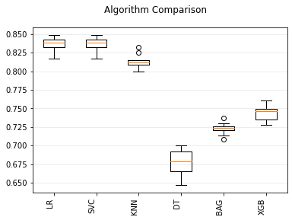

# 

# Milestone - 1

1. EDA - Explore and understand the dataset provided
   1. Visualizing different patterns
   2. Visualizing different text features
   3. Identify data discrepancies
2. Text preprocessing
   1. Dealing with missing values
   2. Text Translation
3. Explore ways to augment the dataset provided without losing the relationship to the target label
4. Creating word vocabulary from the corpus of report text data
5. Creating tokens as required

## Our Approach for Milestone-1

EDA:

* There are 8500 records in the dataset
* Each Dataset contains 4 columns
* The column 'Caller' seems to contain only junk. So we dropped the column
* We identified junk characters using ftfy library
* There were very few columns with Nulls

An example of data that looked like junk at an initial glance. But on applying the ‘fixes text for you - ftfy’ library, we discovered that the data is actually Ticket Description in Chinese Simplifed

Junk text: **ç”µè„‘å¡ä¸”è¿žä¸ä¸Šå†…ç½‘**

Fixed text: **电脑卡且连不上内网**

## 

We discovered this kind of brokenness is called Mojibake

* when someone has encoded Unicode with one standard and decoded it with a different one. This often shows up as characters that turn into nonsense sequences (called “mojibake”)

Fig 1. Distribution of Tickets amongst various groups:

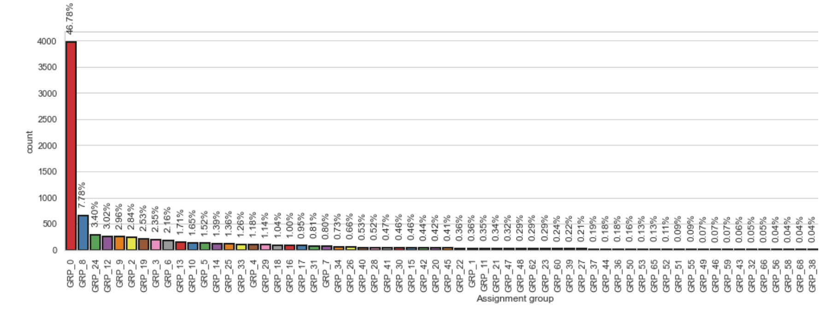

As the figure 1 shows, Group 0 has the most number of tickets, followed by Group 8. The brief (problem statement) provided indicated that about 54% are resolved by L1/L2 groups. Since we also find from the above graph GRP_0 + GRP_8 also equals 54% roughly, we guess GRP_0 is L1 and GRP_8 is probably L2. The remaining groups are probably Functional/L3 teams. (The word cloud for GRP_8 also indicate this group could be related to monitoring tool OR job scheduler)

Some other interesting Figures are below. Fig2 shows the Assignment groups with the highest number of tickets. Figure 3 shows the groups with the lowest number of tickets. Some groups have only 1 ticket. We can choose to discard these groups. BUT, we have chosen a different approach - which we will describe more in the Data Augmentation section. We have done our best NOT to delete any data in the dataset provided. Figure 4 shows a pie chart % distribution by assignment group. Figures 6a, 6b, 6b show the Word Cloud.   
Fig 2.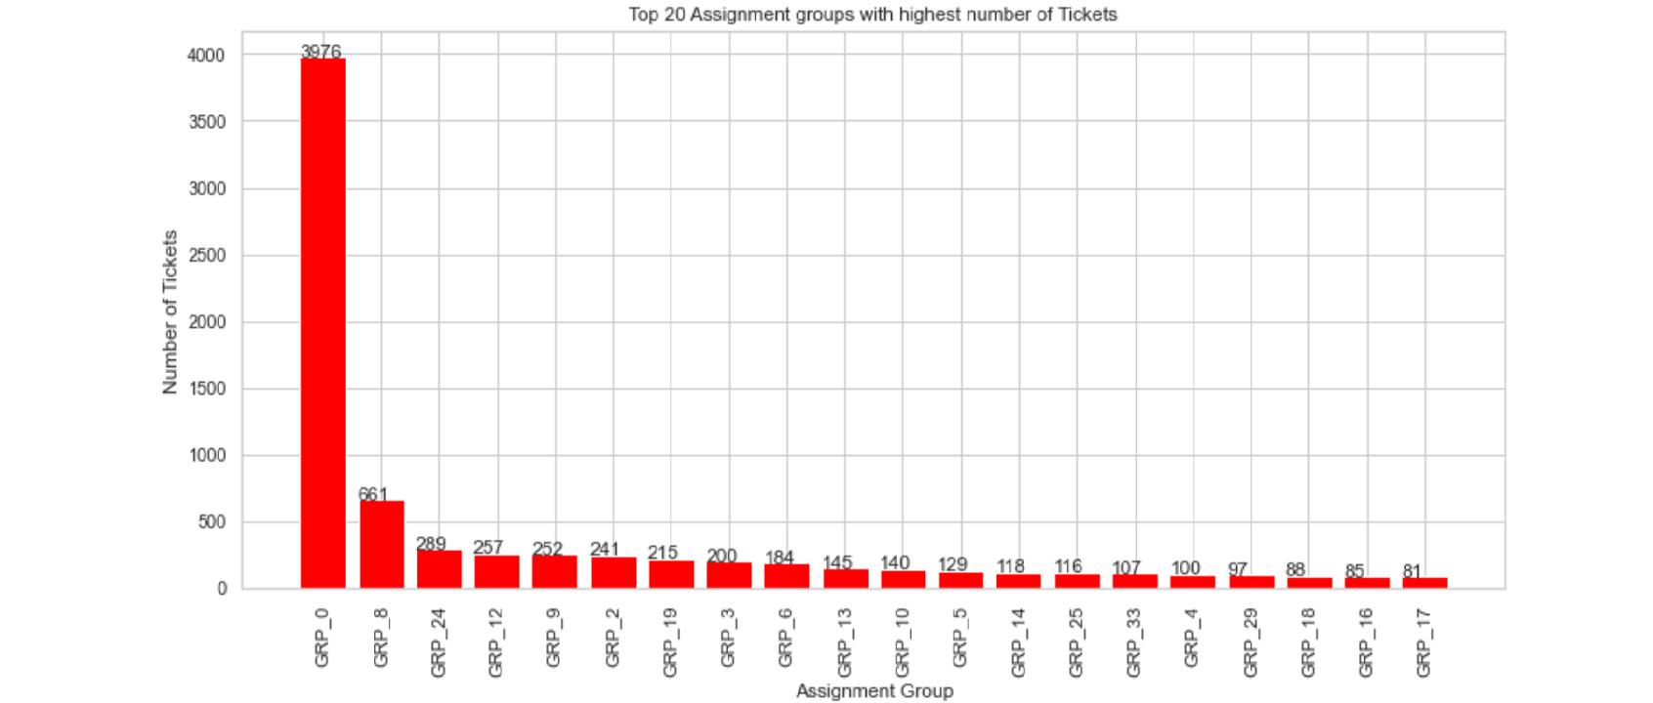

Fig 3.

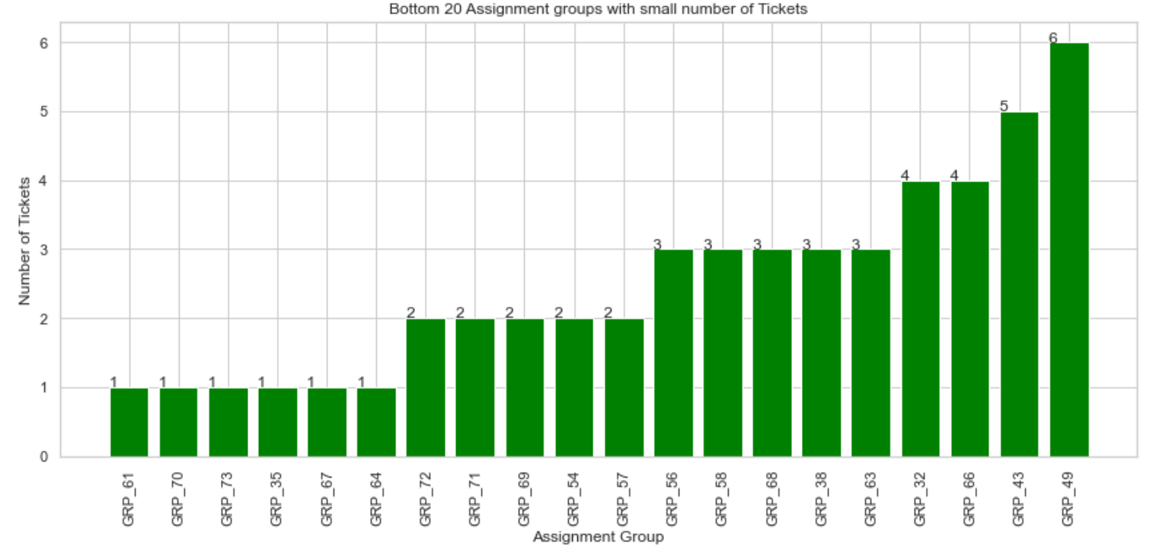

Fig 4.

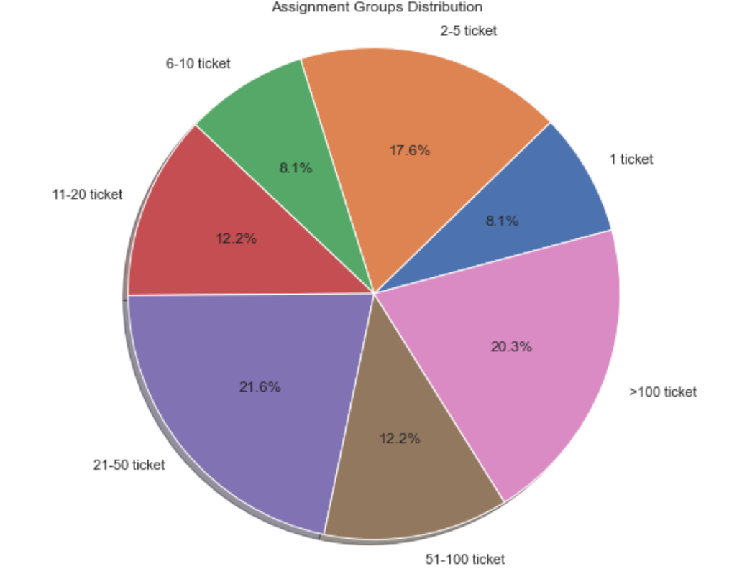

Fig 6a - Word Clouds for GRP_0

* These ticket descriptions indicate issues typically resolved by Help Desk using Standard Operating Procedures



Fig 6b - Word Clouds for GRP_8

The words indicate issues reported by Monitoring tool OR tools like Job Scheduler



Fig 6c Word Cloud for GRP_24

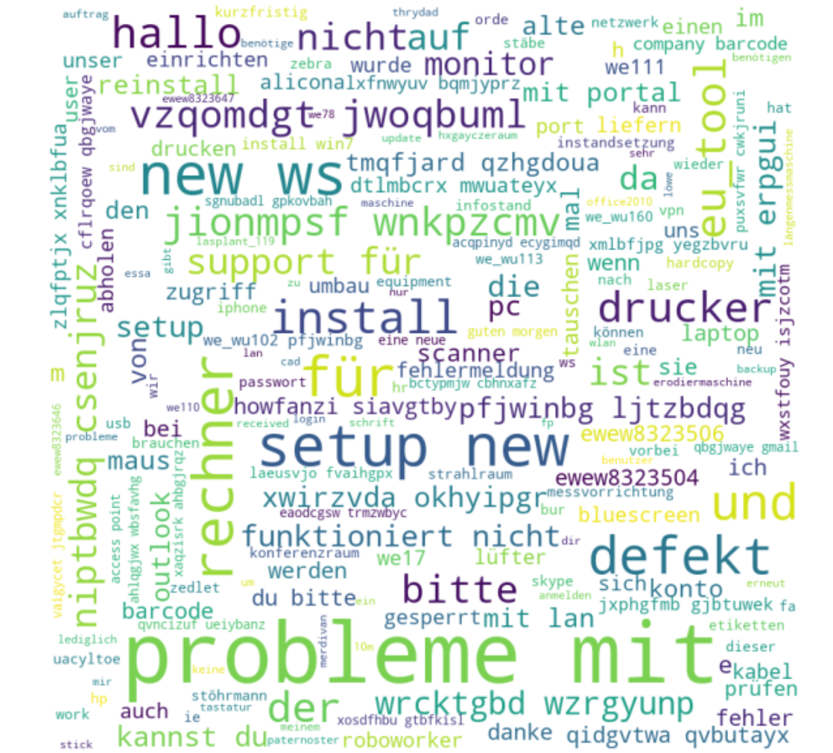

GRP_24 Word Cloud led us into looking into Tickets with languages other than English. We used the Google Translation Engine to look into this further

As Fig 7 shows, most of the Tickets are in English followed by German and Simplified Chinese.

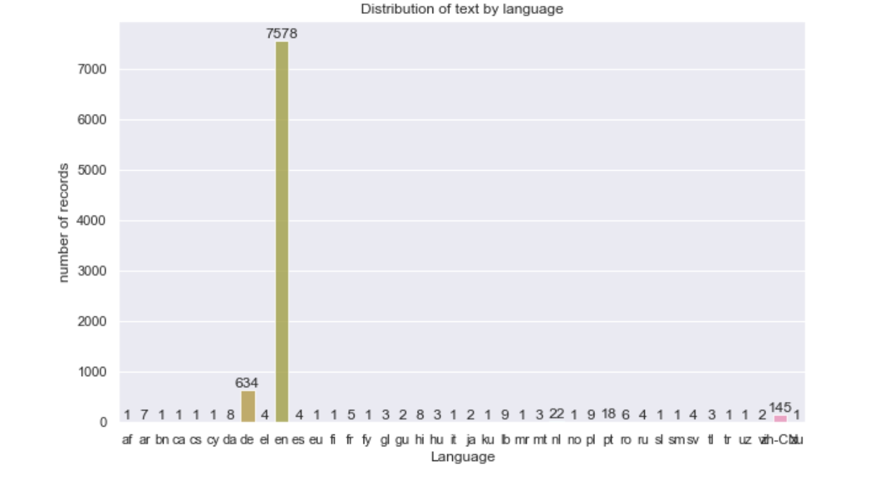

We also found in some tickets, the Short Description and Description were in different languages. An example below where the Description is in english and Shirt Description is in Portuguese

Fig 8.

 

*For more details on the EDA, please review this notebook:* ***capstone_nlp_merged_EDA_Preprocessing_Translation_v13.ipynb***

## Our approach to Pre Processing

So we decided to translate the Short Description and Description fields separately first and then combine them for further preprocessing.

Fig 8 shows the Translated Short Description and Description field of a sample.

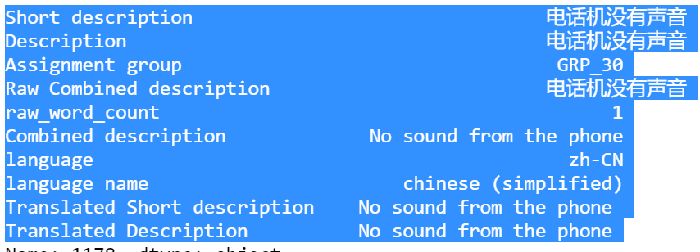

For translation we used the Google Translator API in multithreading mode which performed the translation in a few seconds (all 8500 records)

We also found a couple of records where the Translator got confused so we fixed the data manually.

Fig 9 - In the sample below, the Translator mistook the sentences as Greek. We had to manually fix the data.

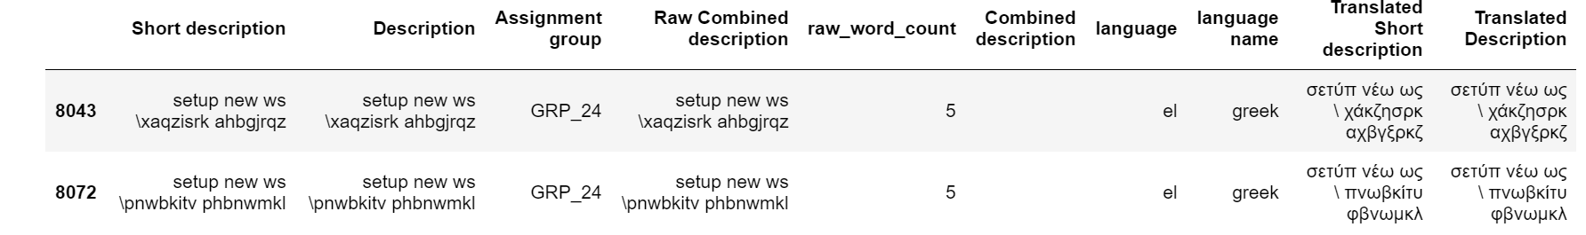

We also fixed about 17 other records manually .

Using the ftfy library, we fixed the junk characters as noted above.

There were a couple of null records with null values for Short Description and Description. We fixed those to empty spaces.

After the translation, we combined the Short Description and Description fields and then applied the logic to remove special characters, numbers and things like email addresses .

*For more details on the Preprocessing, please review this notebook:* ***capstone_nlp_merged_EDA_Preprocessing_Translation_v13.ipynb***

#### Dataset for Deep Learning

The preprocess is still NOT complete, but, at this point, we created the dataset for Deep Learning. The reason we did this is because we wanted to retain the stop words and ‘un lemmatized’ words so the Deep Learning Algorithms will be able to process them in a context sensitive manner.

## EDA (cont’d)

We then used the NLTK library for stopwords in English. We also used punkt and wordnet for lemmatization .

Total Corpus Word Count before lemmatization: 137508

Total Corpus Word Count after lemmatization: 82245

Fig 10. **Top 20 uni-grams, bi-grams & tri-grams**

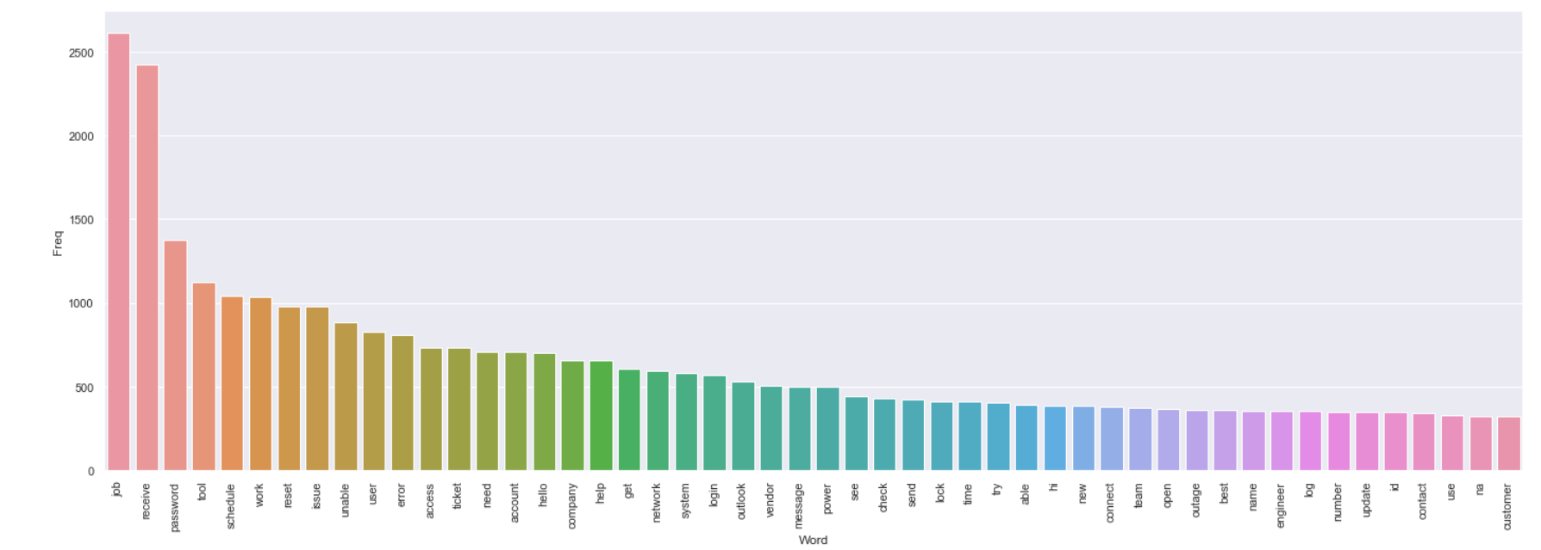

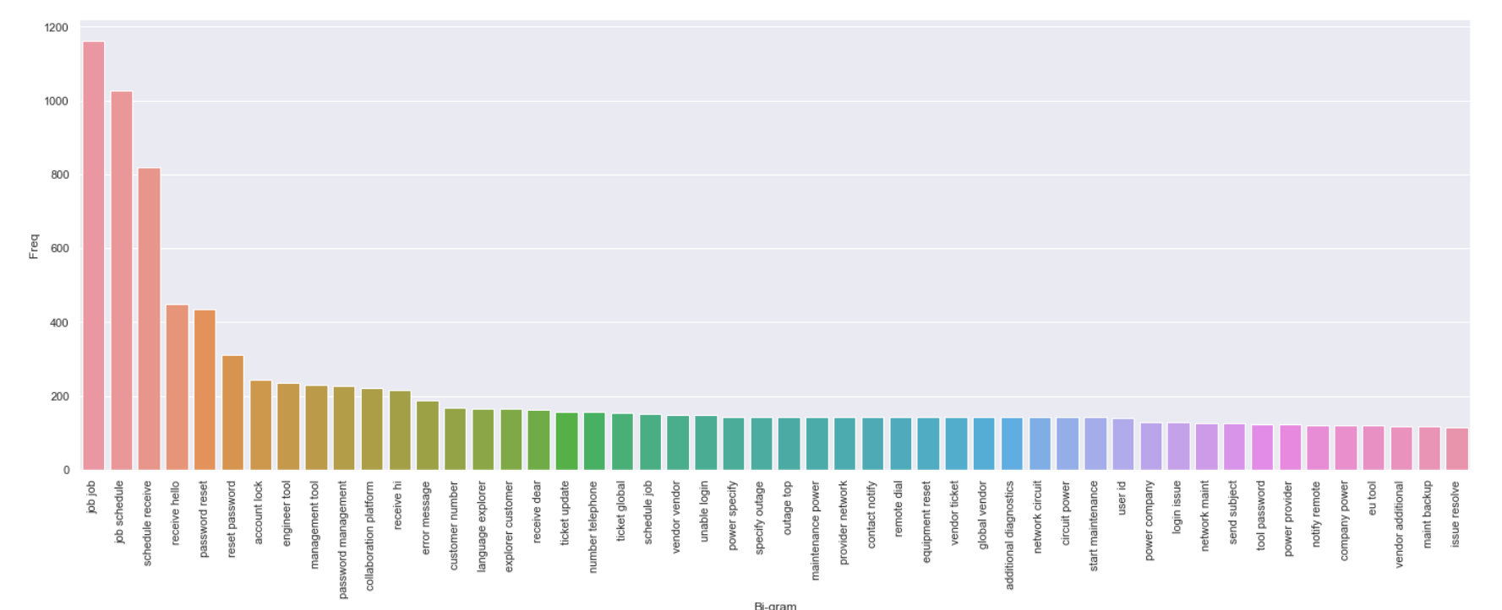

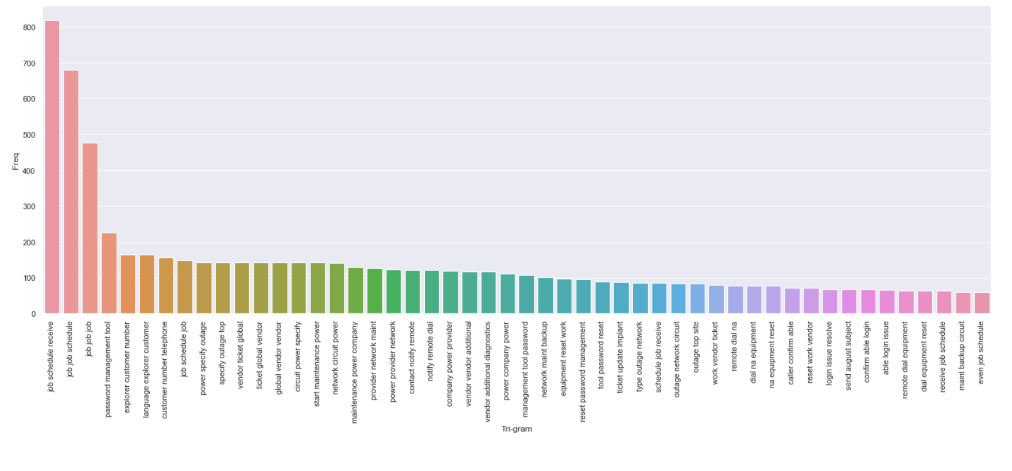

### Document Clustering

We also attempted to use the K-Means algorithm to do Document clustering.

Why is document clustering an important tool in NLP?

Document Clustering is a process of grouping similar items together. Each group, also called as a cluster, contains items that are similar to each other. Clustering algorithms are unsupervised learning algorithms i.e. we do not need to have labelled datasets. There are many clustering algorithms for clustering including KMeans, DBSCAN, Spectral clustering, hierarchical clustering etc and they have their own advantages and disadvantages. The choice of the algorithm mainly depends on whether or not you already know how many clusters to create. Some algorithms such as KMeans need you to specify the number of clusters to create whereas DBSCAN does not need you to specify. Another consideration is whether you need the trained model to be able to predict clusters for unseen dataset. KMeans can be used to predict the clusters for new dataset whereas DBSCAN cannot be used for new dataset.

First we decided on the optimal k - we found the optimal k to be 4 as shown by the ‘elbow method’

These are the clusters:

Cluster:0 contains words like outlook, unable, etc

Cluster: 1 contains words like vendor, outage, etc

Cluster: 2 contains words related password management and reset

Cluster: 3 contains words related to jon schedule



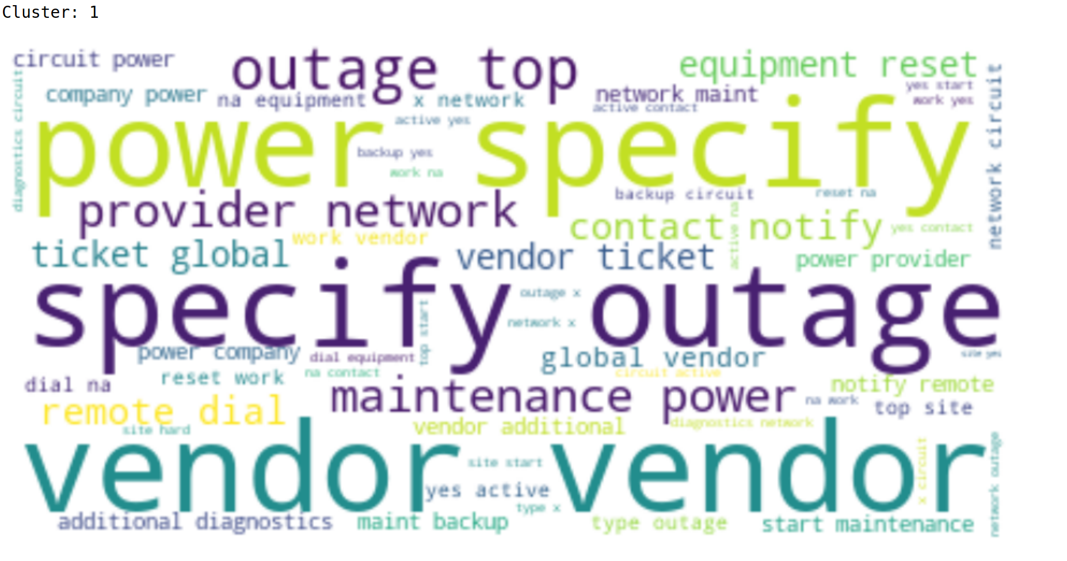

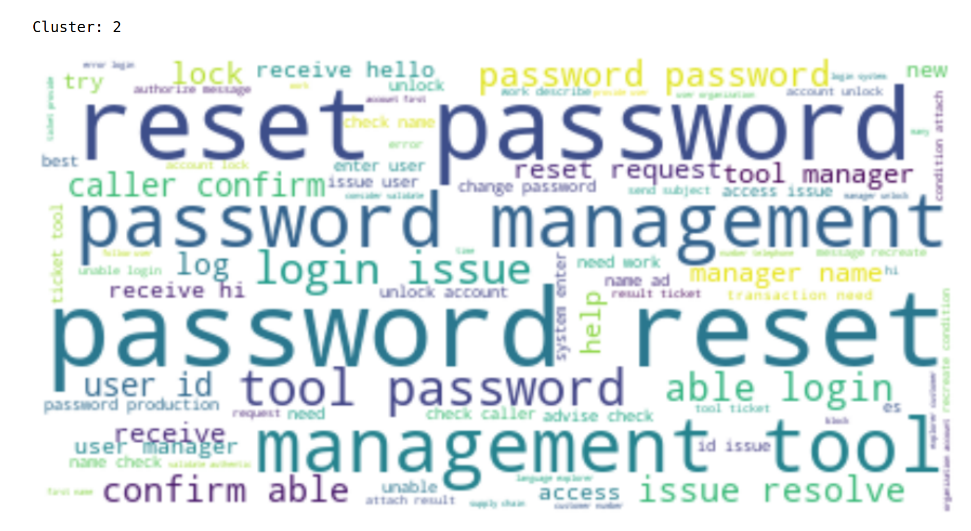

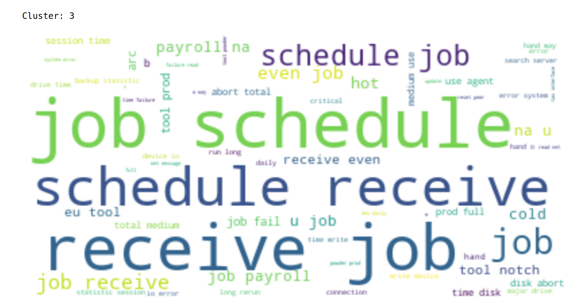

### Topic Modeling (aka Tagging)

Topic modeling is an interesting problem in NLP applications where we want to get an idea of what topics we have in our dataset. A topic is nothing more than a collection of words that describe the overall theme. For example, in case of news articles, we might think of topics as politics, sports etc. but topic modeling won’t directly give you names of the topics but rather a set of most probable words that might describe a topic. It is up to us to determine what topic the set of words might refer to

In our dataset, we identified these words highlighted that seem to suggest the most important topics are job schedule, password resets, account locks, login issues, vendor issues.

0 job schedule receive hot cold payroll na notch prod tool eu fail arc hand way

1 password reset management tool request user manager unlock production change receive es need login id

2 account lock unlock ad user lockout id check login issue hello frequent need team receive

3 unable login outlook issue connect tool access user work error open engineer receive help log

4 ticket update implant vendor power network outage circuit na yes work site global company active

At a later point, we may use these techniques to generate more training data if needed.

## Pre Processing (cont’d)

We used the WordNetLemmatizer to lemmatize the corpus

After lemmatization and word - gram analysis we created the dataset required for the Machine Learning Models.

We also applied spell check and Contraction logic (for example: change "there'd've" to "there would have")

Finally we build the processed dataset required for Machine Learning Models.

*For more details on the Preprocessing, please review this notebook:* ***capstone_nlp_merged_EDA_Preprocessing_Translation_v13.ipynb***

*Our final numbers after preprocessing*

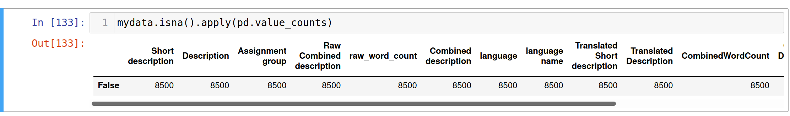

After preprocessing, we ran an initial Model with Logistic Regression. It scored about 62% in accuracy and an f1 score of 57%

Fig 11.

